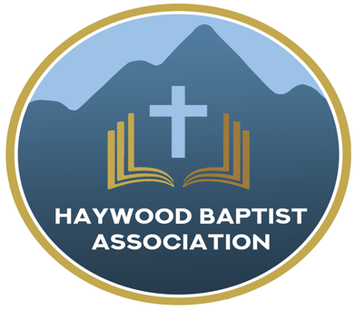
Haywood Baptist Association
Weekly E-News
March 1, 2023

ANNIE?

Little Orphan Annie was a comic strip character I read about when I was a kid. Another Annie I heard about was Annie Oakley—a legendary old west sharpshooter who starred in Buffalo Bill’s Wild West Show.

I don’t want to talk about either of those Annie’s, but one named Annie Armstrong. Our Easter Offering for North American Missions is named for her. She was a prolific supporter of missions both in prayer and fund-raising, so it is altogether appropriate to commemorate her by challenging our Haywood Baptist Association to receive an offering. The week of prayer is upcoming, and I want to encourage you to give.

Vance Pittman shares these five reasons:

- The Annie Armstrong Easter Offering is the financial engine for church planting across North America.

Funds from AAEO are Send Network’s primary financial source to fuel the mission of churches planting churches everywhere for everyone. Every dollar is sent straight to the field to support missionaries in church planting and compassion ministry.

The Annie Offering goes to work in a multitude of ways from assessing new planters, providing training, coaching and ongoing care to church planters and spouses. It is used for evangelism materials and leadership training to help churches send church planters.

Your gifts to AAEO fuel ministry grant that planters can use for Bibles and discipleship materials, neighborhood outreach events, cover rent for worship facilities and much more.

- It’s an opportunity to unite with thousands of other churches.

Send Network is a family of churches planting churches — we are stronger together. Since 1895, Southern Baptist individuals and churches have linked arms to give more than $2 billion to AAEO, enabling missionaries to be sent, churches to be planted and lives to be changed by the gospel.

Leading your church to give to the Annie Armstrong Easter Offering enables you to become part of moving this mission forward and bless others as you have been blessed.

- Church planters and their families get crucial tools and support, allowing them to focus on the work of reaching communities with the gospel.
Send Network offers practical help that enables church planters to plant healthy, multiplying churches. Through the faithful giving of Southern Baptists in 2022, God supplied Send Network with the ability to provide an extra tier of support for new church planters through a strong benefits package.

By addressing this critical need for endorsed planters in their first year of ministry, planters are able to focus on reaching their communities with the gospel. When you lead your church to give to AAEO, it allows for more planters to join the work of expanding God’s kingdom in North America.

- The need is greater than ever.

281 million people are estimated to be lost in North America — one of only two continents in the world where Christianity is declining. As the mission field grows, the costs of ministry are continuing to rise. But you and your church can make a kingdom impact when you invest in AAEO.

By leading your church to give, you will be meeting the urgent spiritual need of North America to be reached with the gospel.

- Giving to AAEO makes an eternal impact across North America, and ultimately among the nations.

The historic results of Southern Baptists’ gifts to AAEO are astounding! Today, AAEO supports 2,400 missionaries and their families as they reach unreached neighborhoods for Christ.

In 2021, Send Network and Southern Baptists came together to add 1,018 new congregations – that’s countless more opportunities to make an eternal impact in North America and beyond, for the glory of God.

Leading your church members to invest in AAEO will multiply the impact of their giving. You and your church will play a part in moving God’s mission forward in North America and beyond by supporting planters and teams already on the field and by sending even more.

Together, we are focused on churches planting churches in North America, that the nations may know Christ. Every local church has a special role in joining in the expansion of God’s kingdom locally and globally.

To join the mission of fueling church planting in North America, and for promotional resources to share this incredible opportunity with your church, visit FueledByAnnie.com.

Yours for Impacting North America with the Gospel,
Dennis Thurman, Mission Strategist
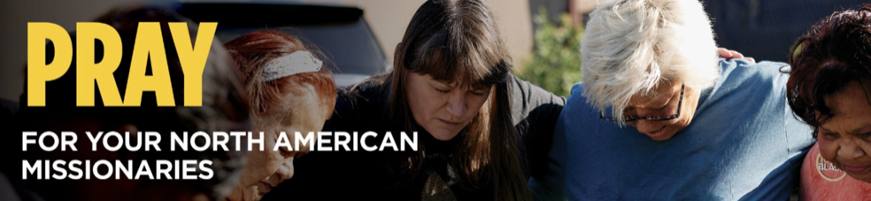

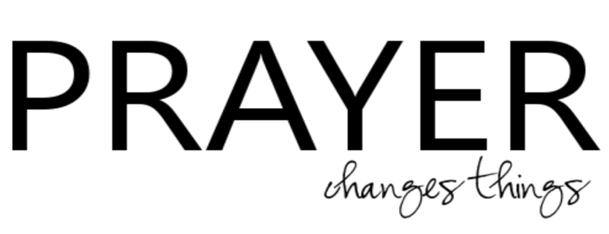

Our AMS Dennis Thurman is inviting everyone to
join him in prayer for our Churches and Pastors:
- Hemphill- Zachary Plemmons
- High Street- Chris Willett
- Casa de Dios- Robert Fernandez

PRAY FOR UKRAINE!
Here is a prayer update from Baptists on Mission concerning Ukraine. Follow the link:
https://baptistsonmission.org/ukraine-crisis

Pastors Conference

Monday morning Pastors Conference are held on Monday Mornings at 10:00AM here at the Associational Office. We would love to have you join!

Men’s Prayer Meeting

The Men’s Prayer Group will meet on Saturday mornings at 7:30AM at Barberville Baptist Church. All are welcome to come!

Employment Opportunities

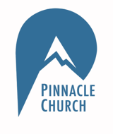
Pinnacle Church is hiring a position in student ministry. This would be to lead the middle school and high school ministries full time. For more information and to apply, please visit: https://pinnacle.elexiochms.com/external/form/34b86081-50b8-4406-9c2e-0a27bb9d37fa

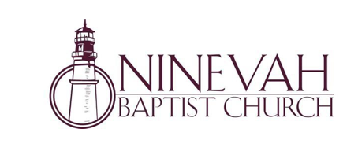
Ninevah Baptist Church is accepting resumes for a part time director of Music Ministries. If interested, please send resumes to PO Box 38. Waynesville, NC 28786

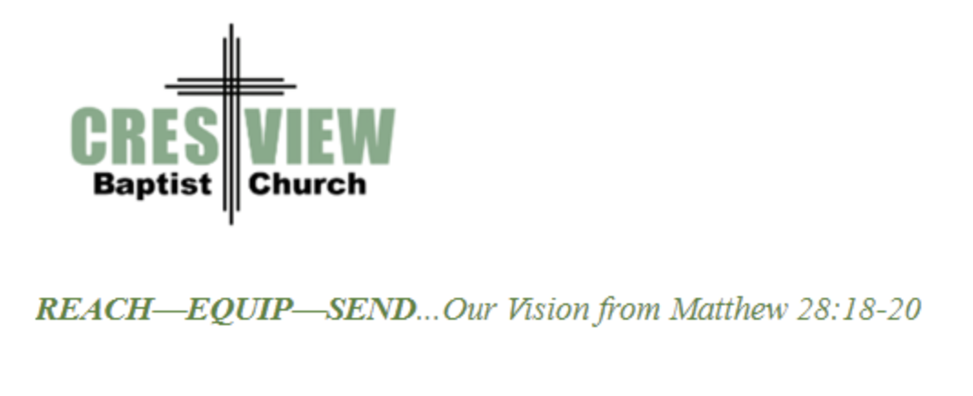
Crestview Baptist Church is now accepting resumes for a part time Worship Leader. If interested, please submit resume to 3258 Pisgah Drive Canton, NC 28716. You can also contact the church at: 828-648-1110 with any questions.

Bible Drill Info:

The Association Bible Drill will be held on Thursday, March 23rd at Mt. Zion Baptist Church. Registration is from 6:00PM-6:20PM and the drills will start at 6:30PM. If your church is planning to participate, please let Lisa Leatherwood know who passed your church drill and will advance to the association drill by Monday, March 20th. You can contact Lisa at: 828-734-3572. Thank You!

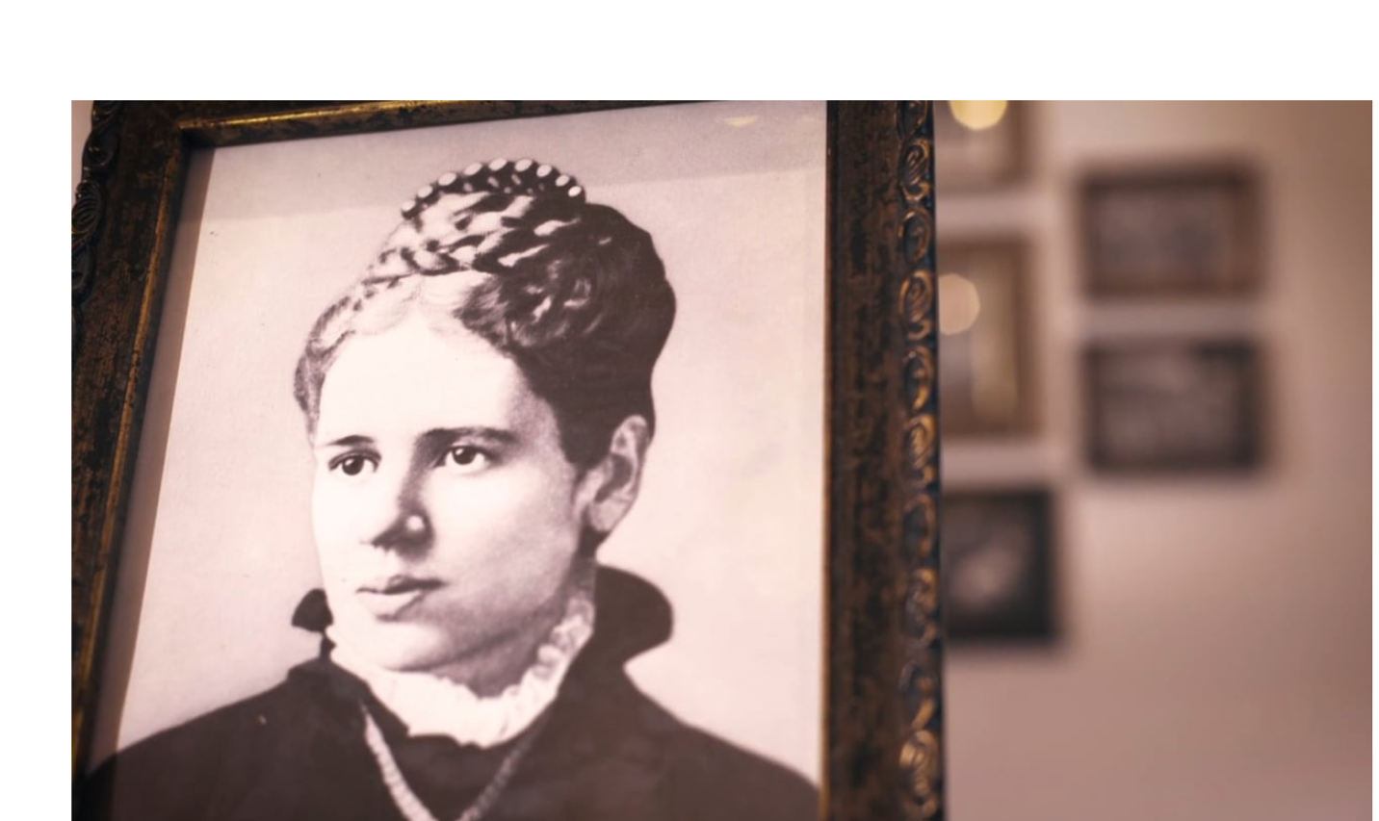

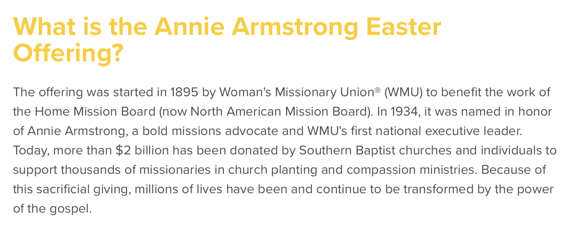

You can learn more information on the Annie Armstrong Easter Offering at:
https://www.anniearmstrong.com

