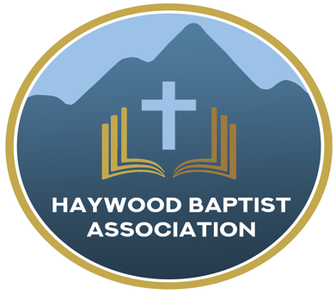
Haywood Baptist Association
Weekly E-News
April 5, 2023

BLESSINGS FROM THE RISEN CHRIST

Jesus is alive! It is not a rumor, myth, lie, or wishful thinking. This Lord's Day we will commemorate the resurrection of Jesus Christ. It is why we gather on the first day for worship each week. God's people celebrate the greatest event of human history!

Because He lives, we are blessed with PEACE, "Then, the same day at evening, being the first day of the week, when the doors were shut where the disciples were assembled, for fear of the Jews, Jesus came and stood in the midst, and said to them, 'Peace be with you.' ... So, Jesus said to them again, 'Peace to you!'" (John 20:19, 21a). Because of the finished work of Christ, sinners can have peace with God. Because of the living presence of Christ, saints can know the peace of God.
Because He lives, we are blessed with PRAISE, "When He had said this, He showed them His hands and His side. Then the disciples were glad when they saw the Lord." (v.20). The despair and tears of death have been overcome by the delight and triumph of resurrection. His people will praise Him in heaven forever!

Because He lives, we are blessed with PURPOSE, "So Jesus said to them again, 'Peace to you! As the Father has sent Me, I also send you.'" (v.21). The grave is not the end. Our life has purpose. Christ's mission is our mission--to tell the good news!

Because He lives, we are blessed with POWER, "And when He had said this, He breathed on them, and said to them, 'Receive the Holy Spirit.'" (v.22). The Risen and Ascended Lord has poured out His Spirit on the church to empower us for our service.
Because He lives, we are blessed with PROCLAMATION, "'If you forgive the sins of any, they are forgiven them; if you retain the sins of any, they are retained.'" (v.23). In the authority of the Resurrected Christ, we can proclaim God's forgiveness for those who believe in Him and confess Him as Lord.

Because He Lives,
Dennis Thurman, Mission Strategist

Our AMS Dennis Thurman is inviting everyone to
join him in prayer for our Churches and Pastors:
- Ratcliffe Cove- Tracy Smith
- Red Bank- Richard Warren
- Rescue- Darrell Shipman

Special Prayer Request

Please remember Lila Murdock in your prayers as she is in Care Partner’s for rehab. Lila is the wife of Paul Murdock, pastor of Calvary Baptist Church in Canton. They will appreciate your prayers during this time!

Pastors’ Conference

There will be NO Pastors’ Conference on Monday, April 10th!

Men’s Prayer Meeting

The Men’s Prayer Group will meet on Saturday mornings at 7:30AM at Barberville Baptist Church. All are welcome to come!

Office Closed
Our office will be closed Monday, April 10, 2023.

Employment Opportunities

Pinnacle Church is hiring a position in student ministry. This would be to lead the middle school and high school ministries full time. For more information and to apply, please visit: https://pinnacle.elexiochms.com/external/form/34b86081-50b8-4406-9c2e-0a27bb9d37fa

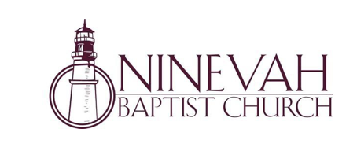
Ninevah Baptist Church is accepting resumes for a part time director of Music Ministries. If interested, please send resumes to PO Box 38. Waynesville, NC 28786

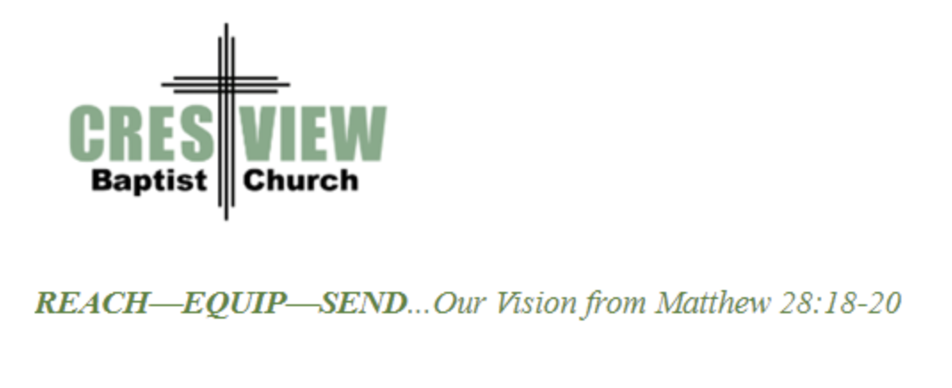
Crestview Baptist Church is now accepting resumes for a part time Worship Leader. If interested, please submit resume to 3258 Pisgah Drive Canton, NC 28716. You can also contact the church at: 828-648-1110 with any questions.

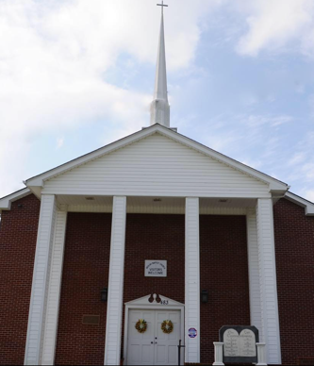

Beulah Baptist Church is looking for a Youth/Children’s Pastor. If you are interested, please contact Pastor Barry Clark at 828-508-8889.

Annie Armstrong Easter Offering

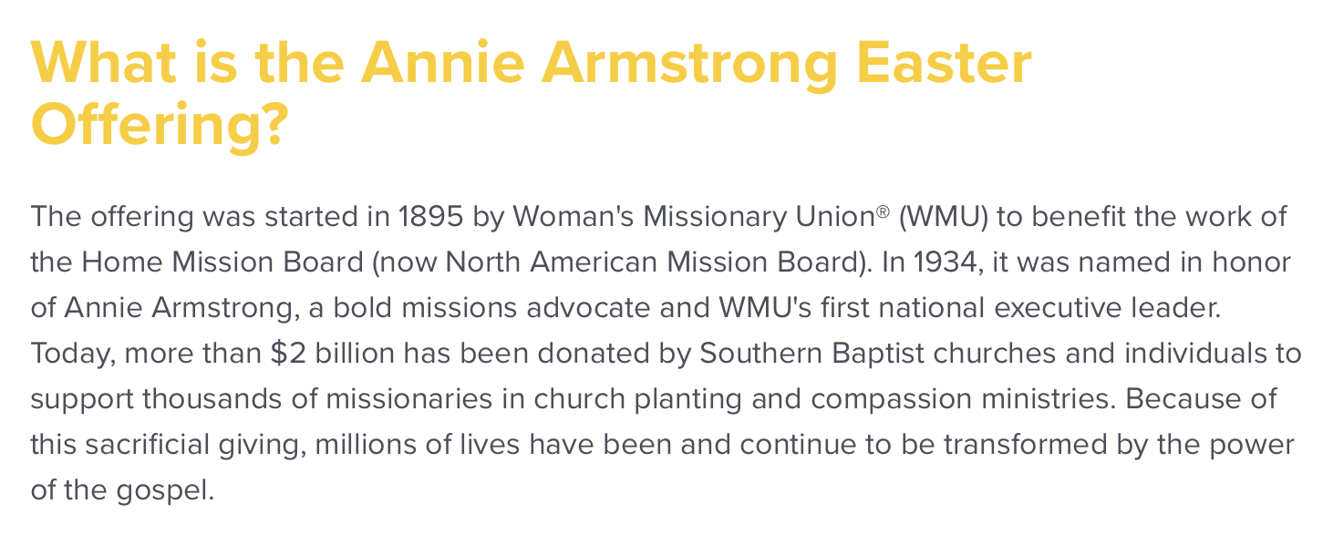

You can learn more information on the Annie Armstrong Easter Offering at:
https://www.anniearmstrong.com

