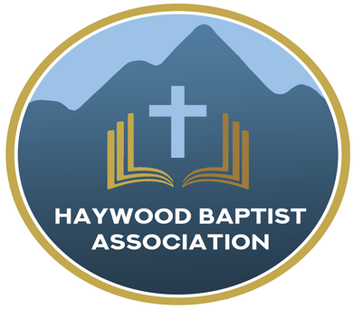
Haywood Baptist Association
Weekly E-News
November 16, 2022

Remembering Our Leaders
"Remember those who rule over you, who have spoken the word of God to you, whose faith follow, considering the outcome of their conduct," (Heb.13:7 NKJV).

We have just come through a month when many churches recognized their pastors for their faithful ministry of the Word. I hope you did. But just because we have entered a new month, does not mean that the call to remember your leaders has expired. Notice, the command--and it is a command--has no time frame.

I am grateful for the men who serve our churches. It will not shock you when I admit that they--like me--are not perfect. We do not deserve to be placed on a pedestal. Yet, I know men who love the Lord and His church. They preach the Word, seek the lost, and minister to those who are hurting. They show up in hospital rooms and funeral homes. They invest many hours in prayer.
Some of our men also are leaders in our denomination and I want to recognize them for their service through the NC Baptist State Convention. Jason Miller, Pastor at Dutch Cove was elected by acclamation as the First Vice President. Elected to our Board of Directors were Josh Evans, Pastor of Crabtree, and Jeff Holder, West Canton Pastor. Nick Smith, Pastor of Lake Junaluska First just finished a term as a member of the Historical Committee. Kris Estep, Barberville Pastor, is a member of the Nominating Committee, on which I served as Chairman.
I am grateful for our leaders--these and others--who are making a difference for the Kingdom of God.

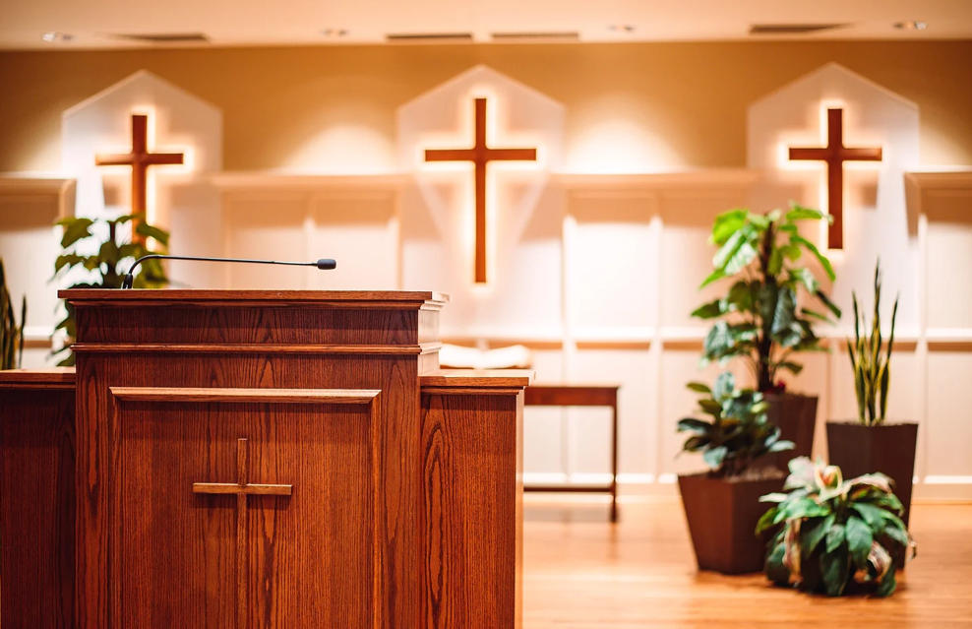
With Gratitude,
Dennis Thurman, AMS

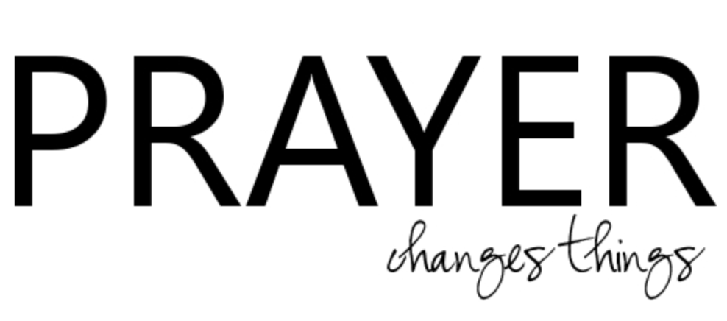

Our AMS Dennis Thurman is inviting everyone to
join him in prayer for our Churches and Pastors:
- Ninevah- Mike Leslie
- North Canton- Marty Nelson
- Oak Grove- Jeff King

PRAY FOR UKRAINE!

Here is a prayer update from Baptists on Mission concerning Ukraine. Follow the link:
https://baptistsonmission.org/ukraine-crisis

MEN’S PRAYER MEETING
We have a prayer meeting at the Associational Office at 7 AM Tuesdays for a time of focused prayer. Pastors, staff, and other men are invited. We will pray for the churches, we will pray through Scripture texts that and asking for God to guide our ministry for the week and bring anointing in our messages, music, and mission.

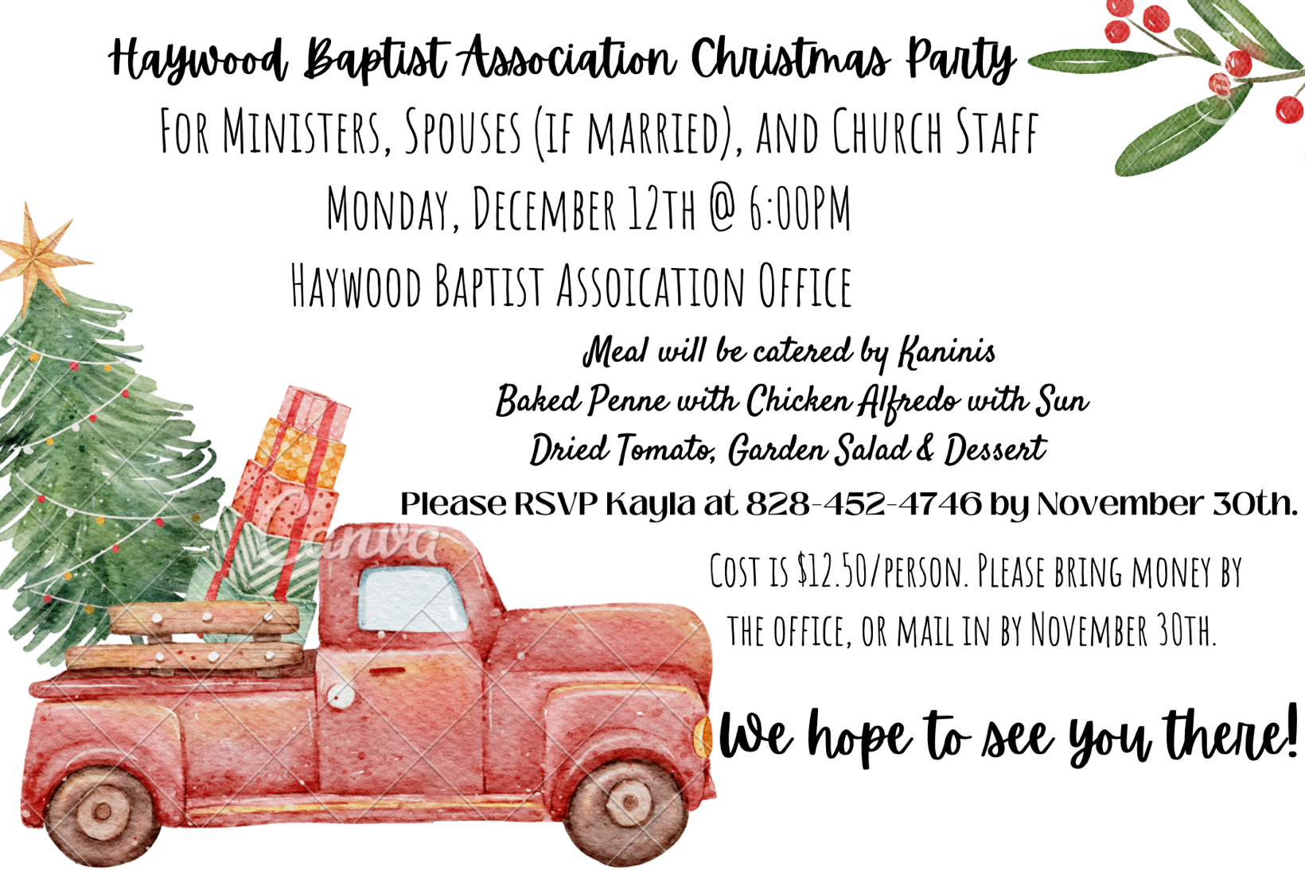

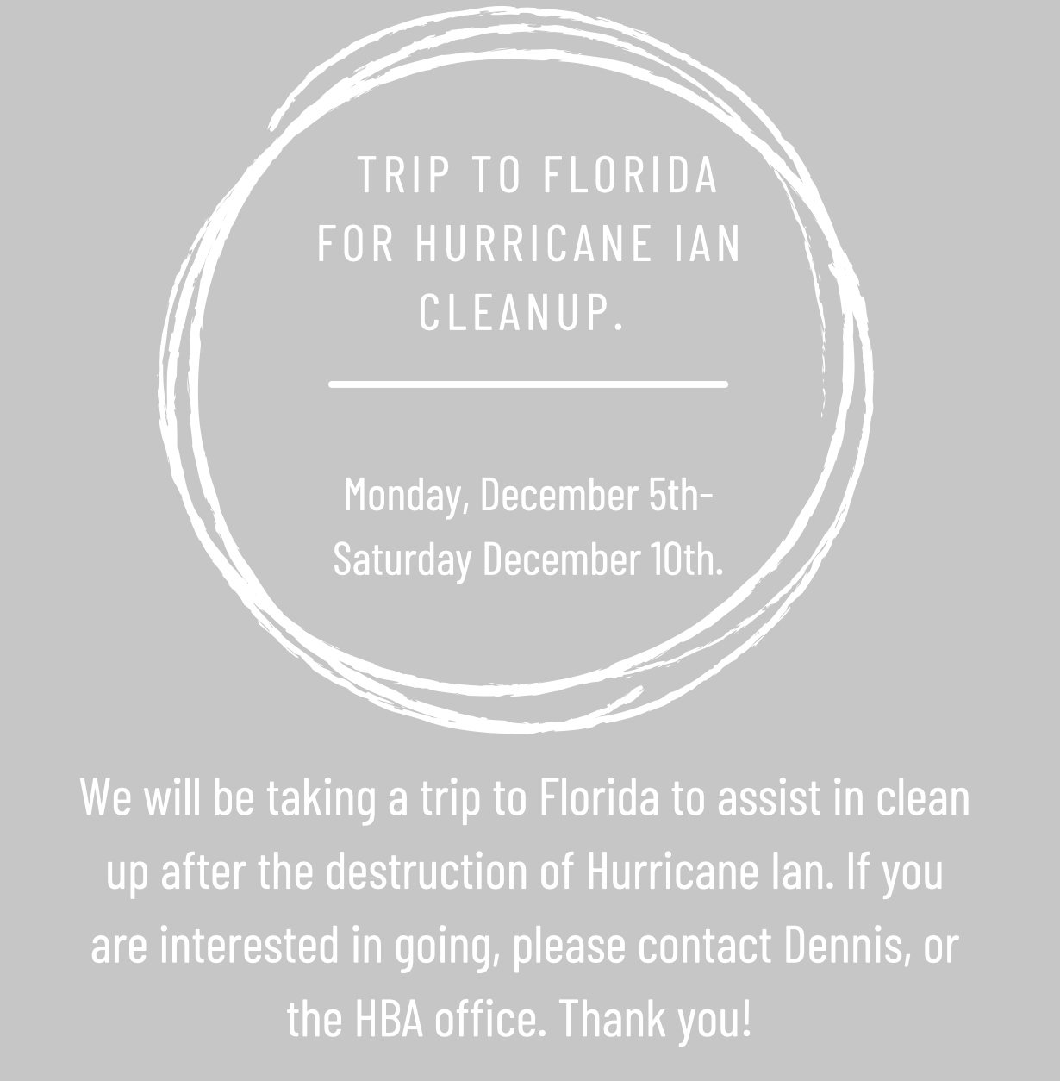

Employment Opportunities.

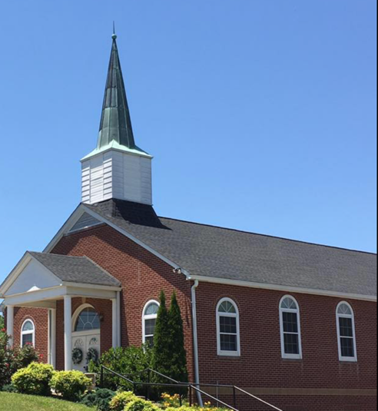
North Canton Baptist Church

North Canton Baptist Church is looking for a Song/Praise Leader. If you are interested, please contact Pastor Marty Nelson at: pastormartynelson@gmail.com

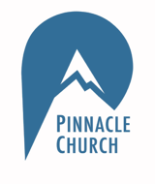
Pinnacle Church is hiring a position in student ministry. This would be to lead the middle school and high school ministries full time. For more information and to apply, please visit: https://pinnacle.elexiochms.com/external/form/34b86081-50b8-4406-9c2e-0a27bb9d37fa

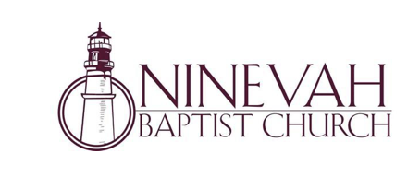

Ninevah Baptist Church is accepting resumes for a part time director of Music Ministries. If interested, please send resumes to PO Box 38. Waynesville, NC 28786

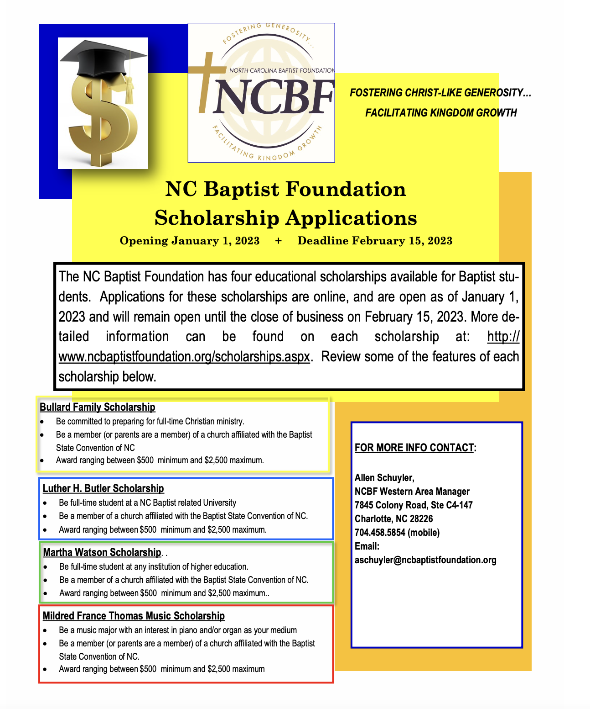

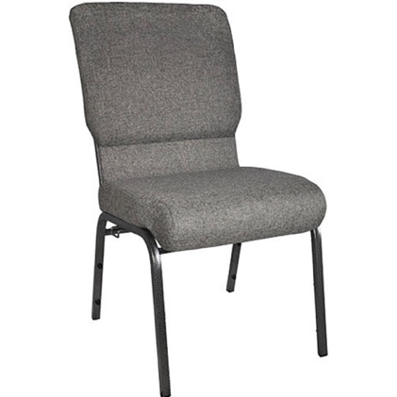

The Hispanic Ministry is needing about 50 chairs like in the picture above. If you would be willing to donate, please contact us!

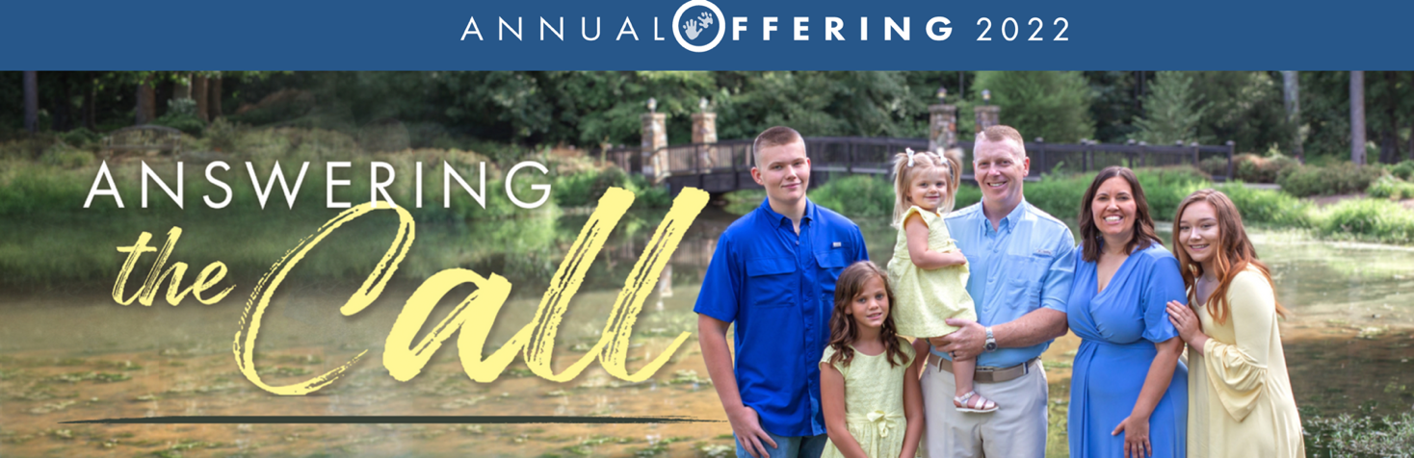

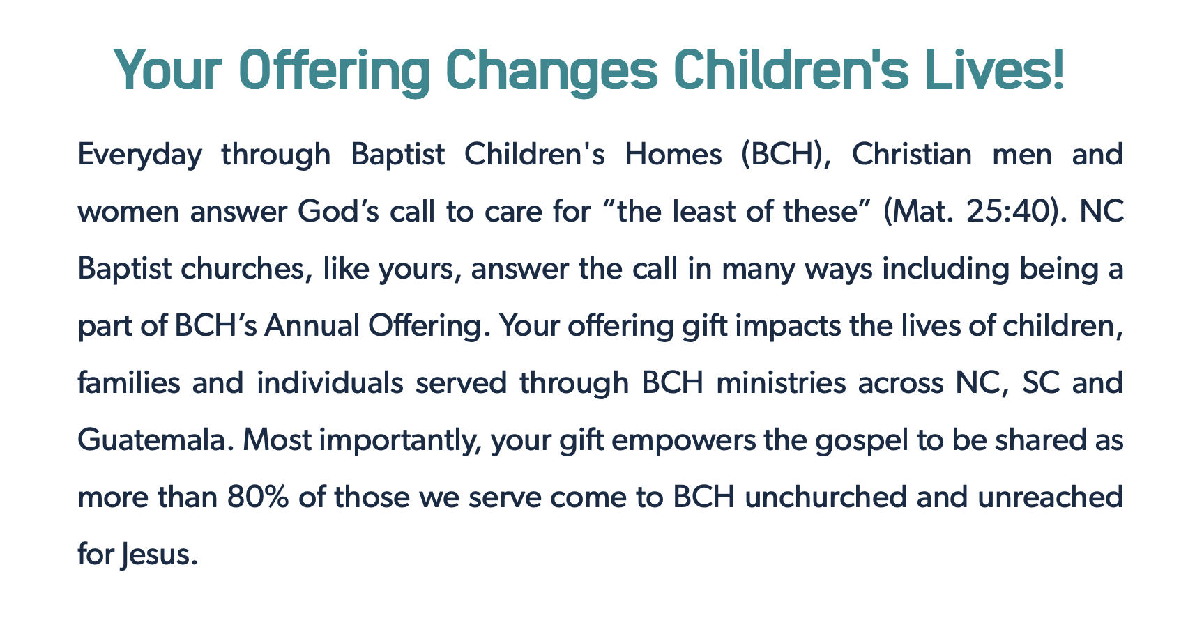

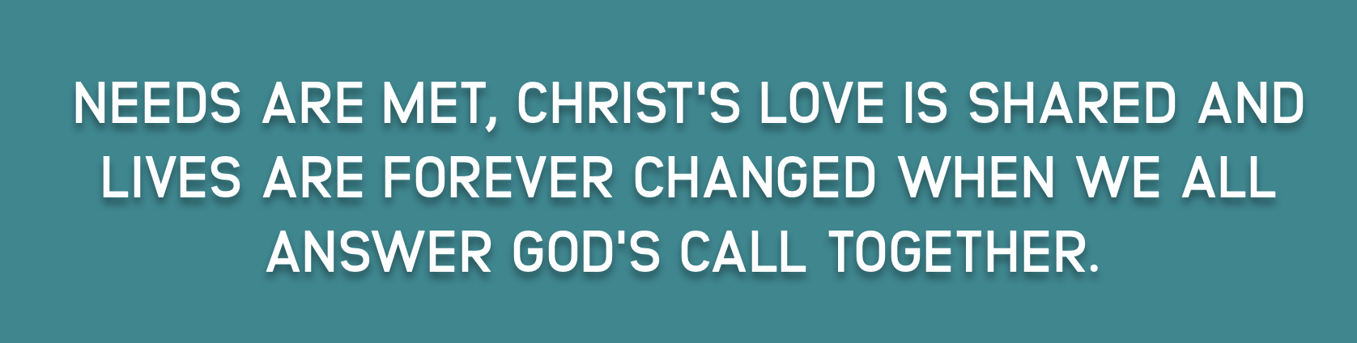

For more information visit: https://www.bchoffering.org

