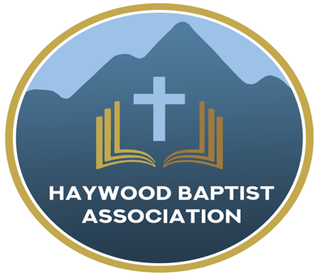
Haywood Baptist Association
Weekly E-News
November 30, 2022

Week of Prayer or Praying Weakly?

This is the season when our Southern Baptist Churches are encouraged to invest a week of prayer for the Lottie Moon Christmas Offering for International Missions. Are we doing that? If we are it a mere routine or earnest intercession? We may say it is a week of prayer but is weak prayer!
Prayer is serious business! Should you ask our missionaries what support they need, they will not speak about money, but request prayer. The money is essential, of course. Yet, while the funds are necessary to keep missionaries on the field, that alone does not assure them of fruitful ministry. No amount of dollars can open a sinner's heart--that is the supernatural work of the Spirit. The old hymn reminds us, "All is vain unless the Spirit of the Holy One comes down; Brethren...sisters...pray and holy manna will be showered all around.”
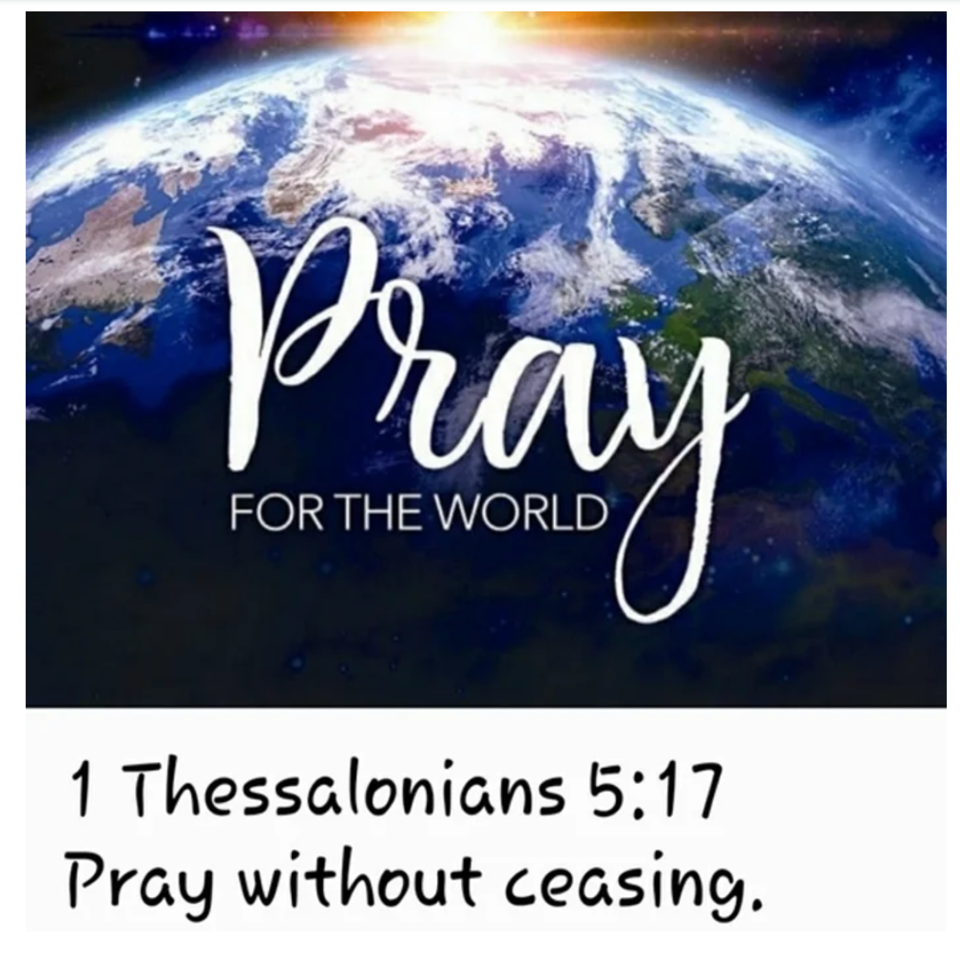
Let me encourage you to get on your knees, give as God directs, and go where He sends.

Yours to Reach the World,
Dennis Thurman, AMS

Our AMS Dennis Thurman is inviting everyone to
join him in prayer for our Churches and Pastors:
- Ratcliffe Cove- Tracy Smith
- Rescue- Darrell Shipman
- Riverside- Steve Frazier

PRAY FOR UKRAINE!
Here is a prayer update from Baptists on Mission concerning Ukraine. Follow the link:
https://baptistsonmission.org/ukraine-crisis

MEN’S PRAYER MEETING
We have a prayer meeting at the Associational Office at 7 AM Tuesdays for a time of focused prayer. Pastors, staff, and other men are invited. We will pray for the churches, we will pray through Scripture texts that and asking for God to guide our ministry for the week and bring anointing in our messages, music, and mission.

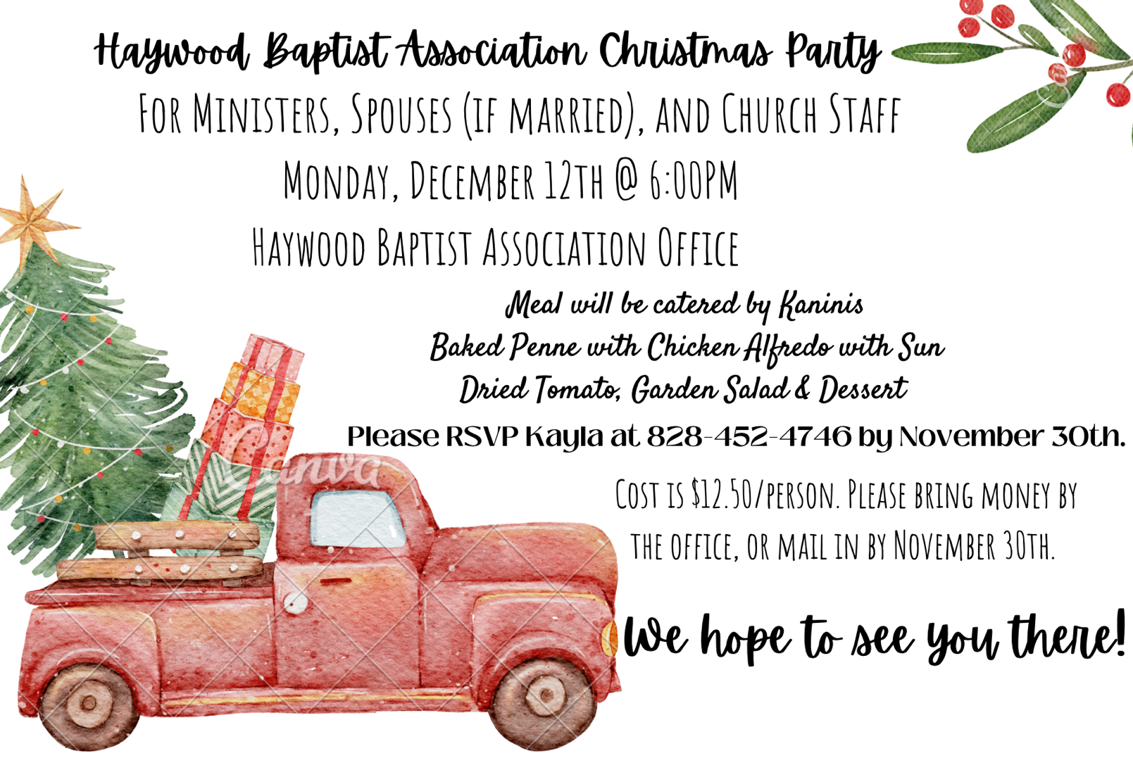

Employment Opportunities.

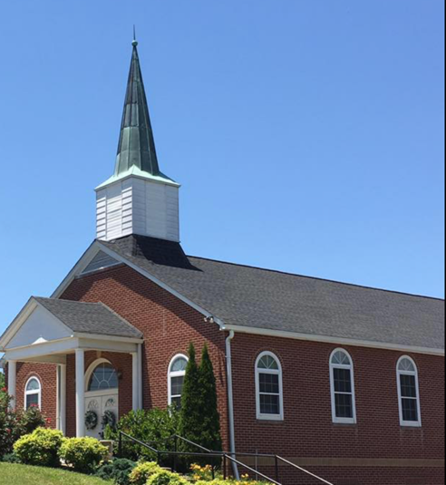
North Canton Baptist Church

North Canton Baptist Church is looking for a Song/Praise Leader. If you are interested, please contact Pastor Marty Nelson at: pastormartynelson@gmail.com

Pinnacle Church is hiring a position in student ministry. This would be to lead the middle school and high school ministries full time. For more information and to apply, please visit: https://pinnacle.elexiochms.com/external/form/34b86081-50b8-4406-9c2e-0a27bb9d37fa

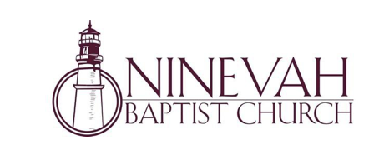
Ninevah Baptist Church is accepting resumes for a part time director of Music Ministries. If interested, please send resumes to PO Box 38. Waynesville, NC 28786

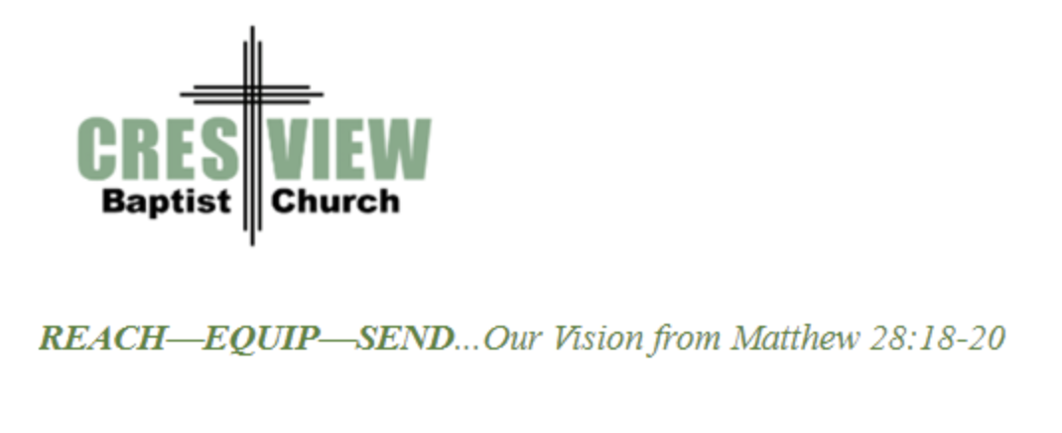
Crestview Baptist Church is now accepting resumes for a part time Worship Leader. If interested, please submit resume to 3258 Pisgah Drive Canton, NC 28716. You can also contact the church at: 828-648-1110 with any questions.

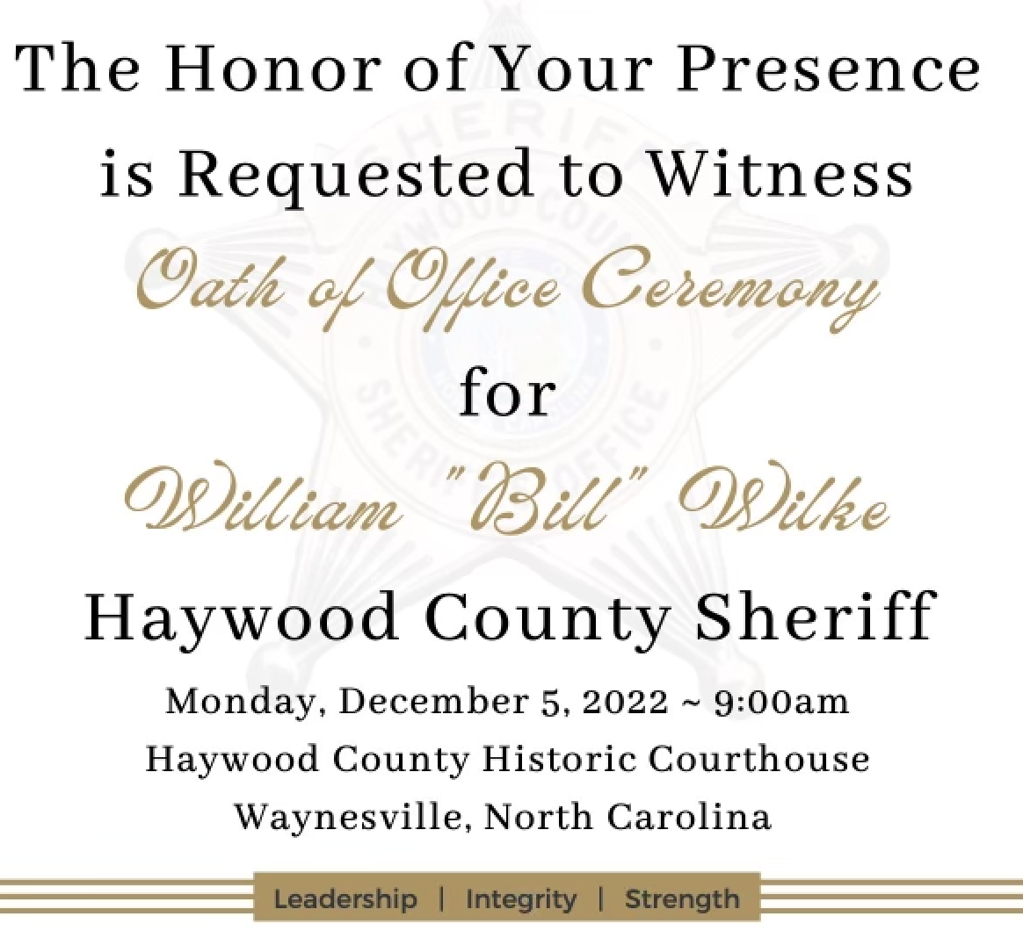

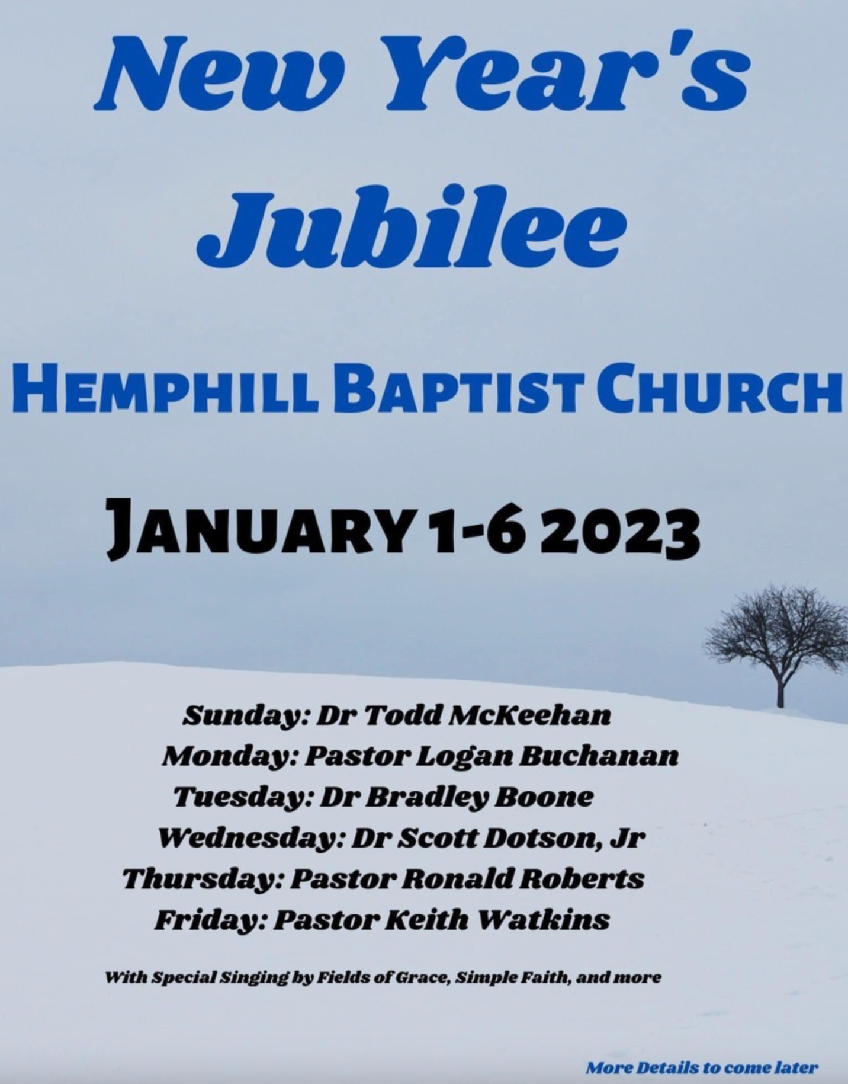

Ministry Opportunities:

There is an opportunity for Gospel ministry in our Haywood County Nursing homes. Wesley Stephens, Mission Pastor at Barberville is organizing this work. He needs volunteers who would be willing to take a turn leading worship service. His goal is to have these slots scheduled beginning with January 2023. So many of these folks are forgotten. The Lord tells us that the real religion concerns visiting the widows (James 1:27). Contact Wesley via email at: pastorwesley@barbervillebaptistchurch.org or call him at :
828-226-4491.

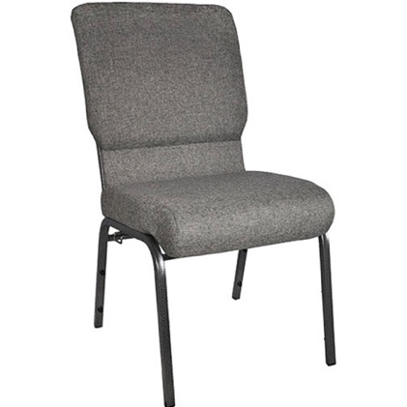
The Hispanic Ministry is needing about 50 chairs like in the picture. The cost is $55.00 per chair. If you would be willing to donate, please contact us!

