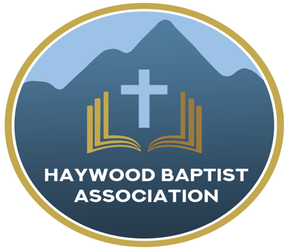
Haywood Baptist Association
Weekly E-News
February 8, 2023

Love Serves

That is both a description and a name. Service is descriptive of what true love does. That is a New Testament message. "Love Serves" is also a title of a parachurch organization that I was able to connect with last week as I traveled to the Dominican Republic. They help lead churches to get involved in Gospel work that declares the life-changing message along with helping them fulfill the Great Commission and Great Commandment to love God and those made in His image by serving them. One of the ways they do this is through a coaching process in working with pastors.
We saw the results. In visiting pastors in the Dominican Republic who had been through this coaching process, we saw a remarkable passion for the Lord and an expanding outreach to the lost and the least. In church after church--inner city, suburban, and rural village, we saw these pastors leading their churches to make a difference in the community. For example, we traveled to an impoverished area at the foot of the mountains, where a church auditorium was filled each week, with as many people standing outside for worship as were seated inside! There had been a time this church just went through the motions with a handful of people. It was a church that the community could ignore. No more!

Of course, this takes the power of God and all glory to Him. Yet, He uses leaders to help other leaders develop. God does the work, but we must employ the tools. So, on Monday, February 20 at our Pastors' Conference, I will share more and via Zoom, we will hear from Peter Swanson who is the President of Love Serves. He is willing to come for a minimal cost each month to offer coaching to a group of pastors. Are you willing to consider this? It could make a dramatic difference in your church for the Kingdom! Here is a link to their website: https://loveserves.org
Serving in Love,
Dennis Thurman, AMS

Our AMS Dennis Thurman is inviting everyone to
join him in prayer for our Churches and Pastors:
- Dutch Cove- Jason Miller
- East Fork- Mark Tice
- Emmanuel- Harry Worley

PRAY FOR UKRAINE!
Here is a prayer update from Baptists on Mission concerning Ukraine. Follow the link:
https://baptistsonmission.org/ukraine-crisis

Pastors Conference

Monday morning Pastors Conference are held on Monday Mornings at 10:00AM here at the Associational Office. We would love to have you join!

Men’s Prayer Meeting

The Men’s Prayer Group will meet on Saturday mornings at 7:30AM at Barberville Baptist Church. All are welcome to come!

Employment Opportunities

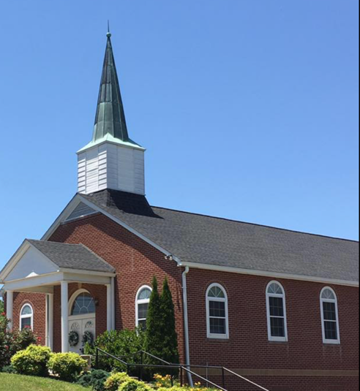
North Canton Baptist Church

North Canton Baptist Church is looking for a Song/Praise Leader. If you are interested, please contact Pastor Marty Nelson at: pastormartynelson@gmail.com

Pinnacle Church is hiring a position in student ministry. This would be to lead the middle school and high school ministries full time. For more information and to apply, please visit: https://pinnacle.elexiochms.com/external/form/34b86081-50b8-4406-9c2e-0a27bb9d37fa

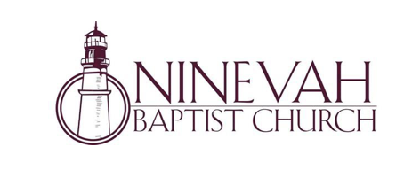
Ninevah Baptist Church is accepting resumes for a part time director of Music Ministries. If interested, please send resumes to PO Box 38. Waynesville, NC 28786

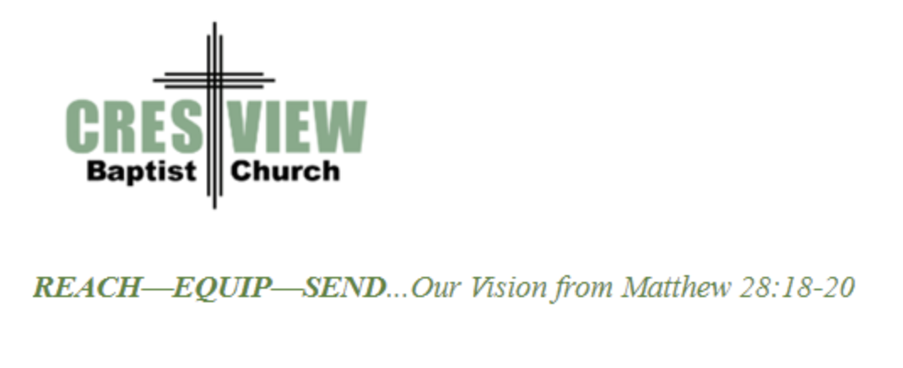
Crestview Baptist Church is now accepting resumes for a part time Worship Leader. If interested, please submit resume to 3258 Pisgah Drive Canton, NC 28716. You can also contact the church at: 828-648-1110 with any questions.

Ministry Opportunity:

There is an opportunity for Gospel ministry in our Haywood County Nursing homes. Wesley Stephens, Mission Pastor at Barberville is organizing this work. He needs volunteers who would be willing to take a turn leading worship service. His goal is to have these slots scheduled beginning with January 2023. So many of these folks are forgotten. The Lord tells us that the real religion concerns visiting the widows (James 1:27). Contact Wesley via email at: pastorwesley@barbervillebaptistchurch.org or call him at :
828-226-4491.

A church within our Association, Laurel Grove Baptist Church is having a difficult time financially. If anyone would like to send a monetary donation, you can do so by mailing to the church address:
Laurel Grove Baptist Church
83 School House Branch Rd.
Canton, NC 28716.

If you have any questions, please contact the pastor of Laurel Grove- Gary Putnam at:
828-734-7197.

You can also send donations to the Association Office, and we will get it to the church.

Thank you!

Bible Drill Info:

The Association Bible Drill will be held on Thursday, March 23rd at Mt. Zion Baptist Church. Registration is from 6:00PM-6:20PM and the drills will start at 6:30PM. If your church is planning to participate, please let Lisa Leatherwood know who passed your church drill and will advance to the association drill by Monday, March 20th. You can contact Lisa at: 828-734-3572. Thank You!

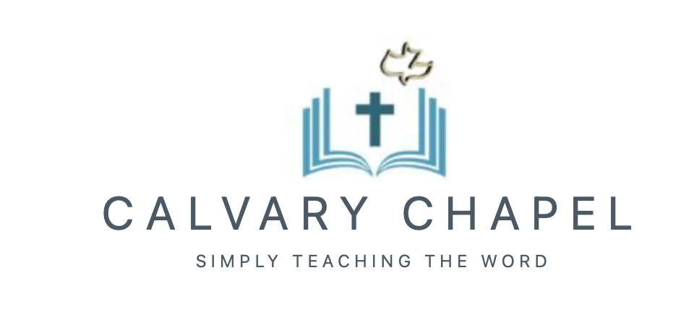

Carl Peetz, pastor of Calvary Chapel in Waynesville attends our Pastor’s Conference regularly and is in search of a place where they can meet. They are looking for a space that has around 30 chairs to seat those in attendance. They are willing to pay around $1,000 a month. If you have a place in mind, please contact Carl.

Also, if anyone is interested in helping Smoky Mountain Cinema be able to show the Jesus Revolution film, please contact Carl also. Here is a link to the movie trailer: www.jesusrevolution.movie

Contact Carl Peetz at:
828-456-4333

Thank You!

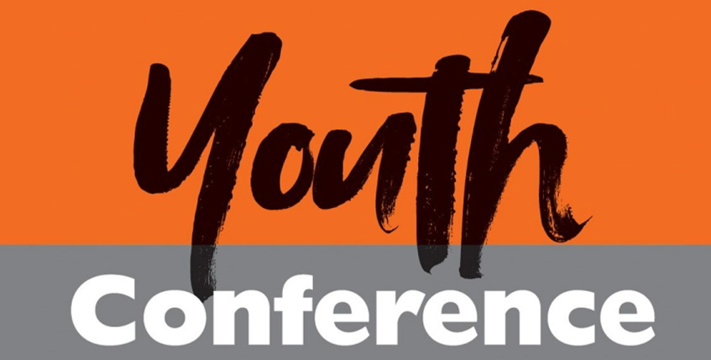

Calvary Chapel is planning a One Day Youth Conference. It will be on Saturday, April 15 from 10AM-4PM with a break for lunch. The speaker will be the General Counsel for the American Family Association, Abraham Hamilton III. They are currently working on getting flyers printed and securing a location for this event. If anyone is interested in learning more about this event, or helping, contact Carl for more information! Below is a summary/overview of the theme of this Conference-

2023 Youth Conference Purpose/Success/God

“We have a purpose and an objective (success), and it’s all based upon a realistic perspective of what life is all about.”
Session 1: What is the purpose of my life:
- How did I get here?
- What am I here?
- What do I perceive to be my purpose in life?

Session 2: How do I define “success”?
- Consistent obedience to God

Session 3: Does God really exist?
- How do we know?
- What do we know about Him?
- What difference does it make in my life and the world at large?
- Ultimately how I view God affects the way I use my time and resources today

Session 4: Q & A

