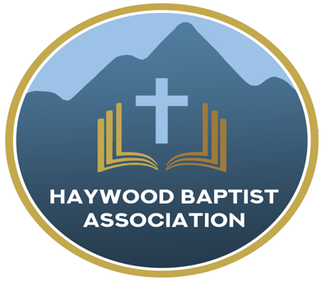
Haywood Baptist Association
Weekly E-News
February 15, 2023

Monday Missionaries

You have likely heard of the sign (you may even have one at your church building), "Enter to Worship; Depart to Serve." It's a Biblical thought, but sometimes there is a short circuit between Sunday and Monday.

One of the most significant mission fields we have is the workplace. Christians, living out their faith by industrious effort first, and then intentional evangelism and discipleship, undergirded by prayer, can have Kingdom Impact.

Maybe we agree but we are not sure where to start. I have come across a book, "The Monday Morning Christian," by Howard Partridge. A friend of mine from Texas is helping to promote it. This would be a wonderful tool for a men's group in the church and/or starting a study at your office or a business leaders' breakfast. A discount for multiple copies is available through my friend. Howard can be scheduled to speak at your church, or even through a zoom meeting. We have several samples at the HBA office if a pastor or Men's Ministry leader would like one.

Here is a link to learn more:
https://howardpartridge.com/mmc-unused/monday-morning-christian/
Blessings,
Dennis Thurman, AMS

Our AMS Dennis Thurman is inviting everyone to
join him in prayer for our Churches and Pastors:
- Encouraging Word- Mike Horton
- Fairview- Jennings Sizemore
- Fines Creek- Josh Skidmore

PRAY FOR UKRAINE!
Here is a prayer update from Baptists on Mission concerning Ukraine. Follow the link:
https://baptistsonmission.org/ukraine-crisis

Pastors Conference

Monday morning Pastors Conference are held on Monday Mornings at 10:00AM here at the Associational Office. We would love to have you join! Dennis Thurman, our AMS will be speaking. We will also participate in a Zoom call with Peter Swanson of Love Serves International.

Men’s Prayer Meeting

The Men’s Prayer Group will meet on Saturday mornings at 7:30AM at Barberville Baptist Church. All are welcome to come!

Employment Opportunities

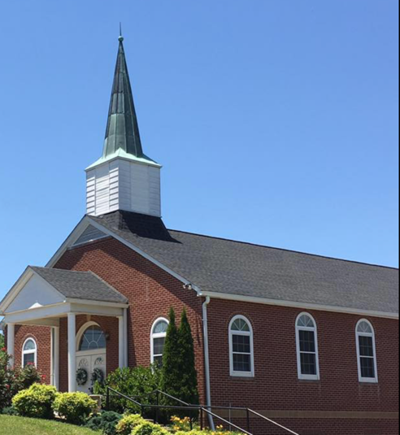
North Canton Baptist Church

North Canton Baptist Church is looking for a Song/Praise Leader. If you are interested, please contact Pastor Marty Nelson at: pastormartynelson@gmail.com

Pinnacle Church is hiring a position in student ministry. This would be to lead the middle school and high school ministries full time. For more information and to apply, please visit: https://pinnacle.elexiochms.com/external/form/34b86081-50b8-4406-9c2e-0a27bb9d37fa

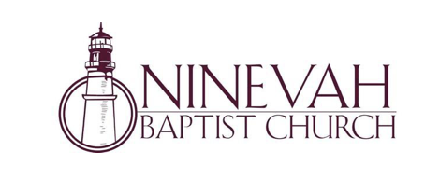
Ninevah Baptist Church is accepting resumes for a part time director of Music Ministries. If interested, please send resumes to PO Box 38. Waynesville, NC 28786

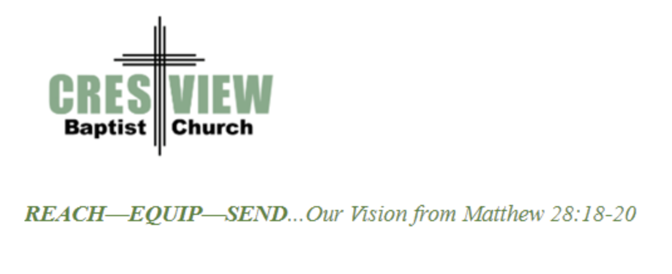
Crestview Baptist Church is now accepting resumes for a part time Worship Leader. If interested, please submit resume to 3258 Pisgah Drive Canton, NC 28716. You can also contact the church at: 828-648-1110 with any questions.

Ministry Opportunity:

There is an opportunity for Gospel ministry in our Haywood County Nursing homes. Wesley Stephens, Mission Pastor at Barberville is organizing this work. He needs volunteers who would be willing to take a turn leading worship service. His goal is to have these slots scheduled beginning with January 2023. So many of these folks are forgotten. The Lord tells us that the real religion concerns visiting the widows (James 1:27). Contact Wesley via email at: pastorwesley@barbervillebaptistchurch.org or call him at :
828-226-4491.

Bible Drill Info:

The Association Bible Drill will be held on Thursday, March 23rd at Mt. Zion Baptist Church. Registration is from 6:00PM-6:20PM and the drills will start at 6:30PM. If your church is planning to participate, please let Lisa Leatherwood know who passed your church drill and will advance to the association drill by Monday, March 20th. You can contact Lisa at: 828-734-3572. Thank You!

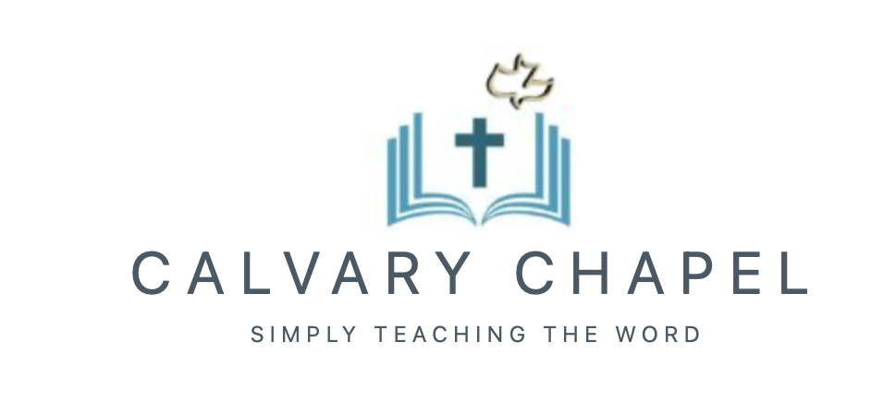

Carl Peetz, pastor of Calvary Chapel in Waynesville attends our Pastor’s Conference regularly and is in search of a place where they can meet. They are looking for a space that has around 30 chairs to seat those in attendance. They are willing to pay around $1,000 a month. If you have a place in mind, please contact Carl.

Also, if anyone is interested in helping Smoky Mountain Cinema be able to show the Jesus Revolution film, please contact Carl also. Here is a link to the movie trailer: www.jesusrevolution.movie

Contact Carl Peetz at:
828-456-4333

Thank You!

Calvary Chapel is planning a One Day Youth Conference. It will be on Saturday, April 15 from 10AM-4PM with a break for lunch. The speaker will be the General Counsel for the American Family Association, Abraham Hamilton III. They are currently working on getting flyers printed and securing a location for this event. If anyone is interested in learning more about this event, or helping, contact Carl for more information! Below is a summary/overview of the theme of this Conference-

2023 Youth Conference Purpose/Success/God

“We have a purpose and an objective (success), and it’s all based upon a realistic perspective of what life is all about.”
Session 1: What is the purpose of my life:
- How did I get here?
- What am I here?
- What do I perceive to be my purpose in life?

Session 2: How do I define “success”?
- Consistent obedience to God

Session 3: Does God really exist?
- How do we know?
- What do we know about Him?
- What difference does it make in my life and the world at large?
- Ultimately how I view God affects the way I use my time and resources today
Session 4: Q & A

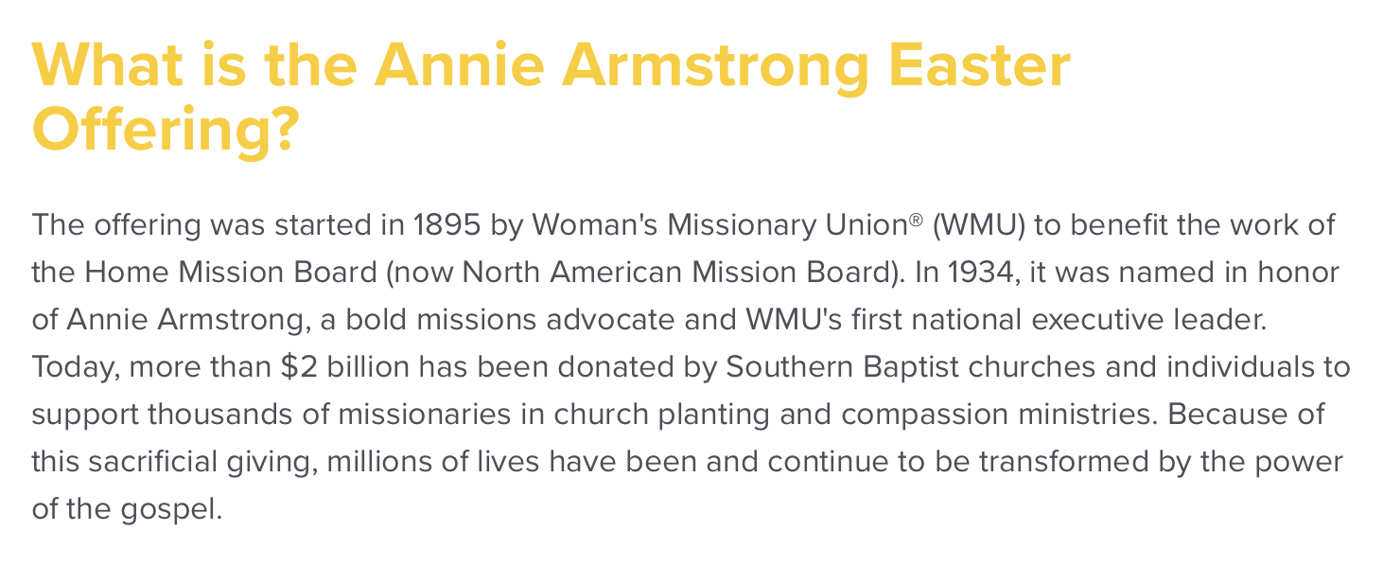

You can learn more information on the Annie Armstrong Easter Offering at:

https://www.anniearmstrong.com

