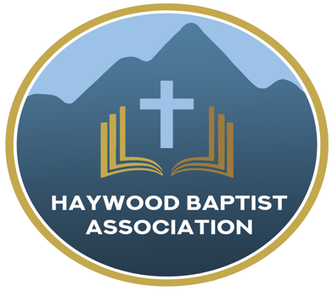
Haywood Baptist Association
Weekly E-News
July 5, 2023

ADDING VALUE

The local church is the headquarters for God's mission and ministry on earth--the visible expression of the body of Christ. Associations of churches, however, are Biblical. For an overview, here is an excellent summary:
https://www.9marks.org/article/journalcooperative-ministry-new-testament/

Our association of Baptist churches, under my leadership in Haywood County, seeks to add value to your congregation. You do not exist to serve the Haywood Baptist Association, but we exist to serve you!
Let me suggest several ways an association adds value:
- EFFECTIVENESS. We are better together. A lady playing a piano and singing, or a guy strumming on a guitar doing a solo can surely be a blessing. Yet, it takes it up a notch when there is the harmony of multiple voices and a symphony of many instruments. Each enhances the other, and so do we in church life.
- ENCOURAGEMENT. The burdens of the repetitive nature of day-to-day ministry can be depleting. The crises that often arise may be depressing. Discouragement sets in when we feel like we are alone in our work. But, we can encourage and be encouraged as we serve alongside each other.
- EFFICIENCY. We all have blind spots. It is easy to become distracted by activity and fail to do what brings accomplishment. Our ax gets dull. But, "As iron sharpens iron, So a man sharpens the countenance of his friend," (Prov.27:17). The tyranny of the urgent can eclipse the assignment of God. Having others as a sounding board can help us be more efficient. They can be a lens to bring clarity to our task.
- EXAMPLE. God is love and His people are to be marked by love. Jesus said that is how you recognize His disciples. In our unity as churches (not uniformity as we may differ in secondary matters) but bound together in truth and love--conviction and compassion--we set an example of Christ to our lost community!
We do want to add value to your ministry. I pray for you on a regular basis. I am willing to serve you in any way I can help. Just ask!

Your Mission Strategist,
Dennis Thurman

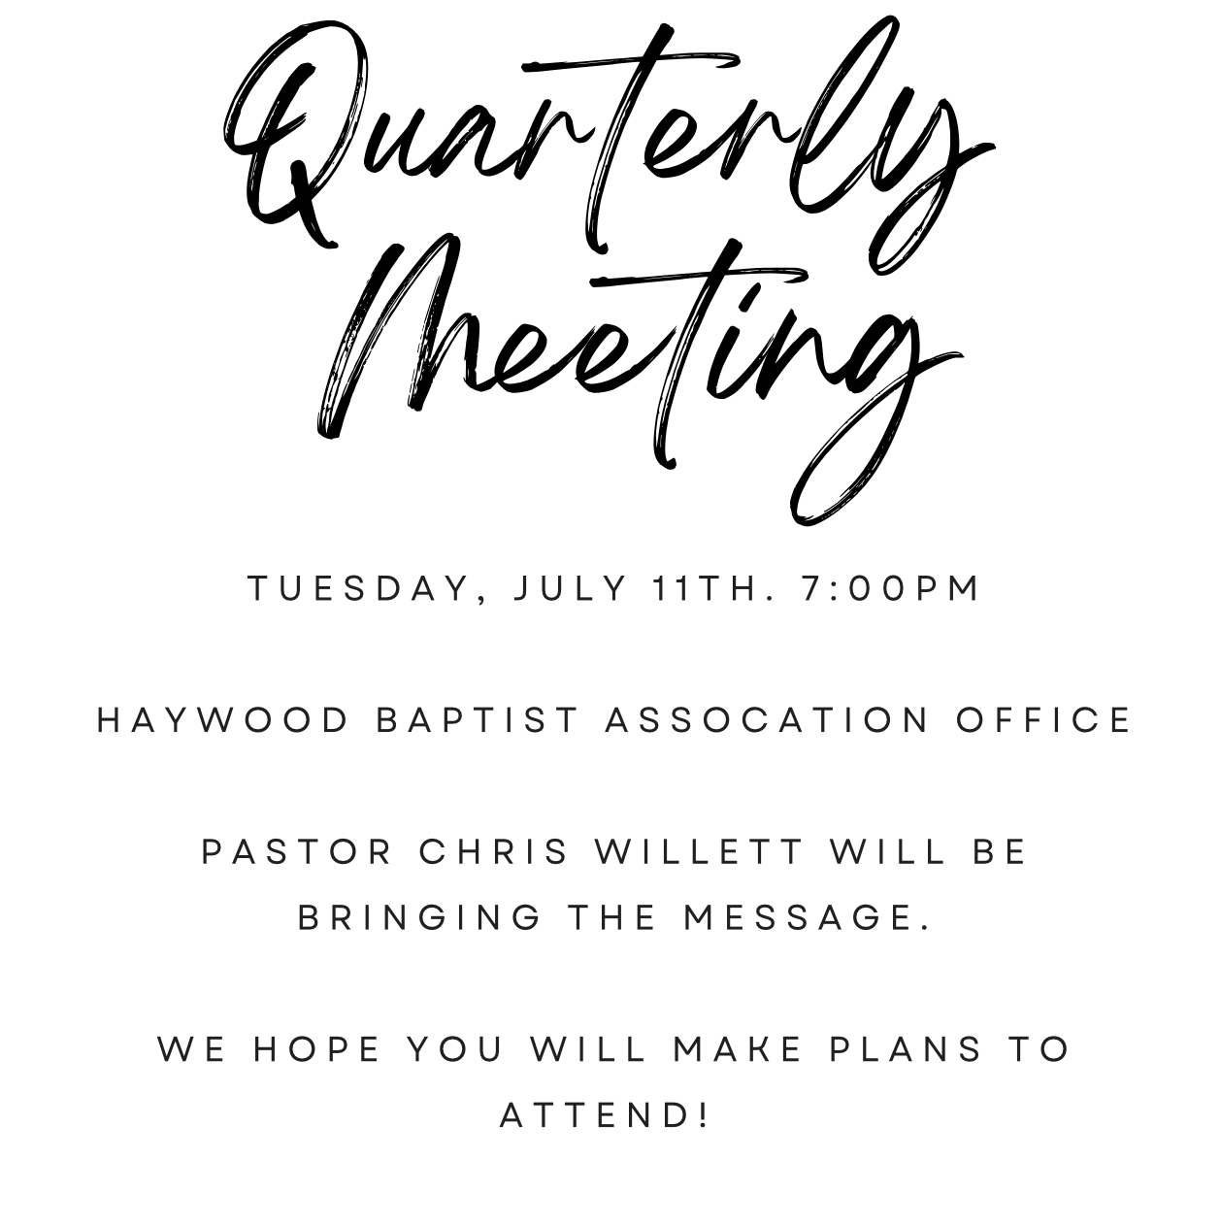

Our AMS Dennis Thurman is inviting everyone to
join him in prayer for our Churches and Pastors:
- Hazelwood- Tim Lolley
- Hemphill- Zachary Plemmons
- High Street- Chris Willett

Special Prayer Request
Please remember Lila Murdock in your prayers. Lila is the wife of Paul Murdock, pastor of Calvary Baptist Church in Canton.

Employment Opportunities:
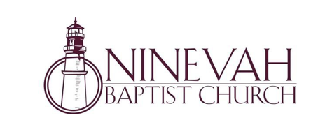
Ninevah Baptist Church is accepting resumes for a part time director of Music Ministries. If interested, please send resumes to PO Box 38. Waynesville, NC 28786

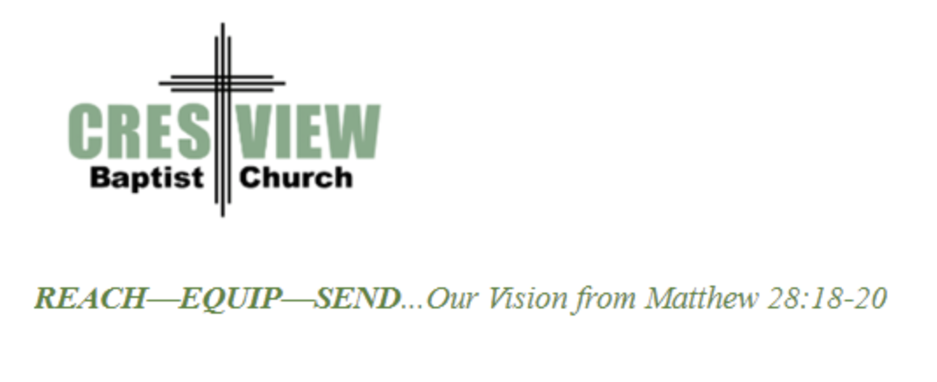
Crestview Baptist Church is now accepting resumes for a part time Worship Leader. If interested, please submit resume to 3258 Pisgah Drive Canton, NC 28716. You can also contact the church at: 828-648-1110 with any questions.

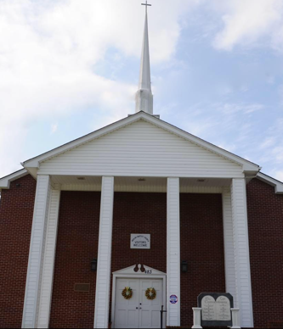
Beulah Baptist Church is looking for a Youth/Children’s Pastor. If you are interested, please contact Pastor Barry Clark at 828-508-8889.

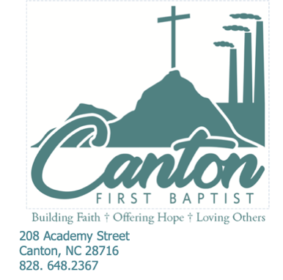

Canton First Baptist Church is looking for a part-time Youth/Children Director. If interested, please submit a resume to 208 Academy Street. Canton, NC 28716, or via e-mail at cfbc202@gmail.com. You can also contact the church at 828-648-2367

