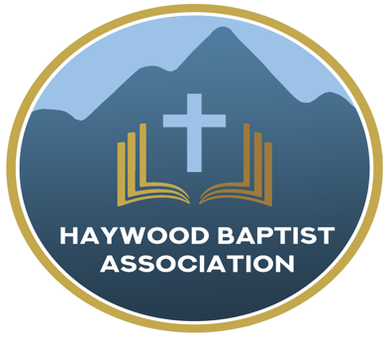
Haywood Baptist Association
Weekly E-News
February 1, 2023

Ministry to and with Seasoned Saints

I love senior adults--I am one! I understand that if we do not reach a younger generation, the local church will age and die as we do, but that does not mean we have to neglect ministry to and with seasoned saints! God wants His church to be multi-generational! Paul speaks of how younger men are to be discipled by older men and the elderly women are to teach the younger women how to be the wife, mother, and godly saint God desires (cf. Titus 2:1-10).

There is no excuse for your church not to grow. Last week, Anita Davies with NC Baptist Aging Ministries was with us to help us in outreach to Senior Adults. On our website, you can access the recording of her training. So much practical information is available on the NCBAM website. Here is the link:
https://ncbam.org

Please get involved. Pray about how God can use you.

Your Brother,
Dennis Thurman, AMS

P.S. Please pray for me as I am in the Dominican Republic exploring mission opportunities.

Our AMS Dennis Thurman is inviting everyone to
join him in prayer for our Churches and Pastors:
- Crabtree- Josh Evans
- Crestview- Dan Page
- Dellwood- Bobby Rogers

PRAY FOR UKRAINE!
Here is a prayer update from Baptists on Mission concerning Ukraine. Follow the link:
https://baptistsonmission.org/ukraine-crisis

Pastors Conference

Monday morning Pastors Conference are held on Monday Mornings at 10:00AM here at the Associational Office. We would love to have you join!

Men’s Prayer Meeting

The Men’s Prayer Group will meet on Tuesday’s at 8:00AM at Barberville Baptist Church.

Employment Opportunities

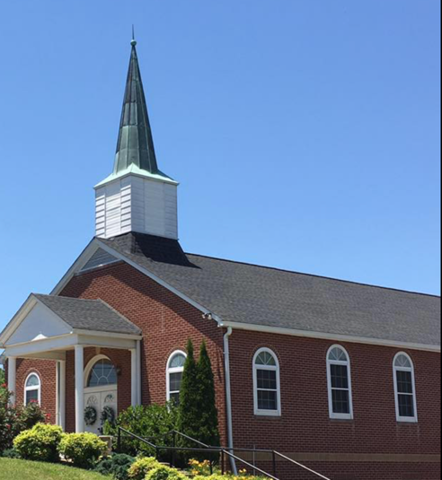
North Canton Baptist Church

North Canton Baptist Church is looking for a Song/Praise Leader. If you are interested, please contact Pastor Marty Nelson at: pastormartynelson@gmail.com

Pinnacle Church is hiring a position in student ministry. This would be to lead the middle school and high school ministries full time. For more information and to apply, please visit: https://pinnacle.elexiochms.com/external/form/34b86081-50b8-4406-9c2e-0a27bb9d37fa

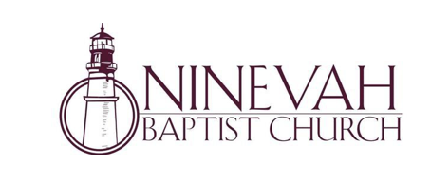
Ninevah Baptist Church is accepting resumes for a part time director of Music Ministries. If interested, please send resumes to PO Box 38. Waynesville, NC 28786

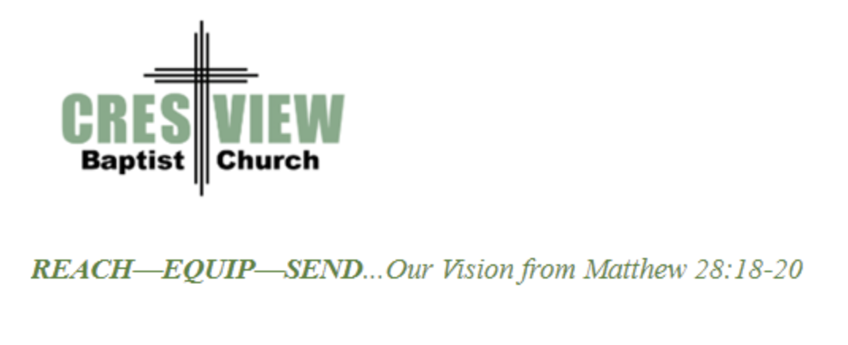
Crestview Baptist Church is now accepting resumes for a part time Worship Leader. If interested, please submit resume to 3258 Pisgah Drive Canton, NC 28716. You can also contact the church at: 828-648-1110 with any questions.

Ministry Opportunity:

There is an opportunity for Gospel ministry in our Haywood County Nursing homes. Wesley Stephens, Mission Pastor at Barberville is organizing this work. He needs volunteers who would be willing to take a turn leading worship service. His goal is to have these slots scheduled beginning with January 2023. So many of these folks are forgotten. The Lord tells us that the real religion concerns visiting the widows (James 1:27). Contact Wesley via email at: pastorwesley@barbervillebaptistchurch.org or call him at :
828-226-4491.

A church within our Association, Laurel Grove Baptist Church is having a difficult time financially. If anyone would like to send a monetary donation, you can do so by mailing to the church address:
Laurel Grove Baptist Church
83 School House Branch Rd.
Canton, NC 28716.

If you have any questions, please contact the pastor of Laurel Grove- Gary Putnam at:
828-734-7197.

You can also send donations to the Association Office, and we will get it to the church.

Thank you!

Bible Drill Info:

The Association Bible Drill will be held on Thursday, March 23rd at Mt. Zion Baptist Church. Registration is from 6:00PM-6:20PM and the drills will start at 6:30PM. If your church is planning to participate, please let Lisa Leatherwood know who passed your church drill and will advance to the association drill by Monday, March 20th. You can contact Lisa at: 828-734-3572. Thank You!

