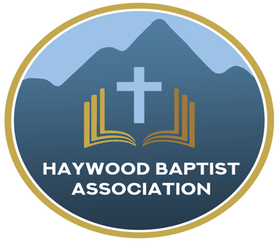
Haywood Baptist Association
Weekly E-News
December 14, 2022

FUN, FOOD, AND FELLOWSHIP

We gathered with pastors, wives, and staff at Haywood Baptist Associational Office for a Christmas party. It was a time of fun, food, and fellowship. I just wish more of our pastors and staff members had been able to attend, but I know it is an incredibly busy time. God willing, we will do this each year, and perhaps those who could not join us will be able to do so next time.

My dear wife organized it and furnished the desserts. Kanini's catered it. Our Administrative Assistant, Kayla Mashburn helped us, with her husband Cody. Janet Frazier planned the games. Steve Frazier was the comedian. I gave a Christmas sermon outline. I will share that in a future newsletter.
We are here to support and encourage the leaders of our churches. It is a big responsibility to shepherd God's flock. I pray for you regularly. If I can serve you in any way, please let me know!

Blessings,
Dennis Thurman, Haywood AMS
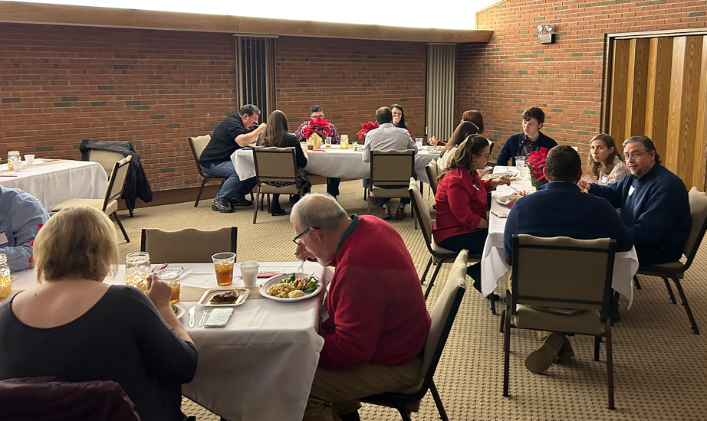

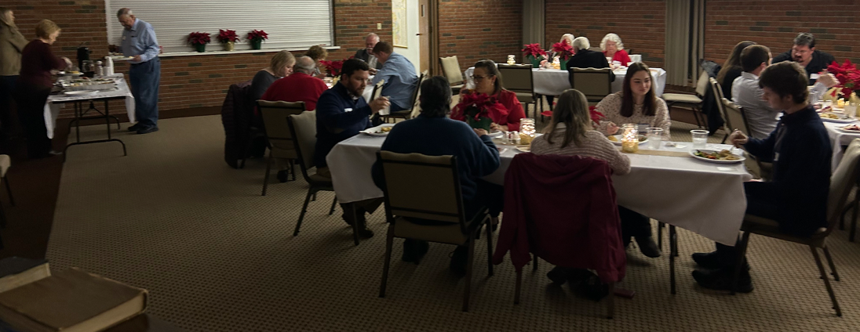

Our AMS Dennis Thurman is inviting everyone to
join him in prayer for our Churches and Pastors:
- The Orchard- Steven Buys
- Victory- Jerry Nelson
- Waynesville First- Robert Prince

PRAY FOR UKRAINE!
Here is a prayer update from Baptists on Mission concerning Ukraine. Follow the link:
https://baptistsonmission.org/ukraine-crisis

Haywood Baptist Association Holiday Schedule:

Monday, December 26th- Office CLOSED

Monday, January 2nd- Office CLOSED
Employment Opportunities.

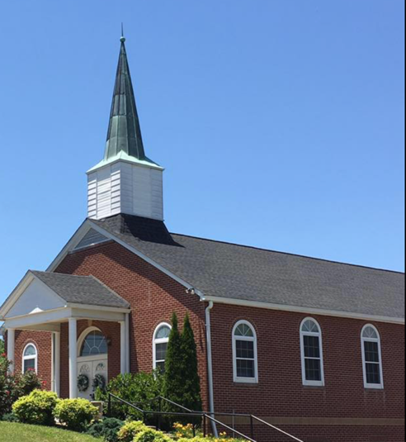
North Canton Baptist Church

North Canton Baptist Church is looking for a Song/Praise Leader. If you are interested, please contact Pastor Marty Nelson at: pastormartynelson@gmail.com

Pinnacle Church is hiring a position in student ministry. This would be to lead the middle school and high school ministries full time. For more information and to apply, please visit: https://pinnacle.elexiochms.com/external/form/34b86081-50b8-4406-9c2e-0a27bb9d37fa

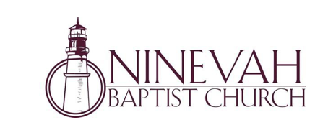
Ninevah Baptist Church is accepting resumes for a part time director of Music Ministries. If interested, please send resumes to PO Box 38. Waynesville, NC 28786

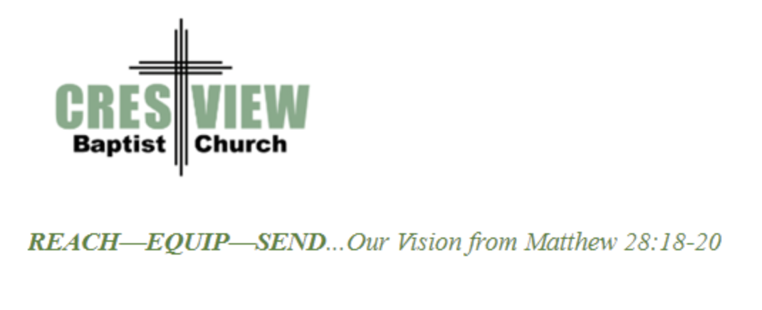
Crestview Baptist Church is now accepting resumes for a part time Worship Leader. If interested, please submit resume to 3258 Pisgah Drive Canton, NC 28716. You can also contact the church at: 828-648-1110 with any questions.

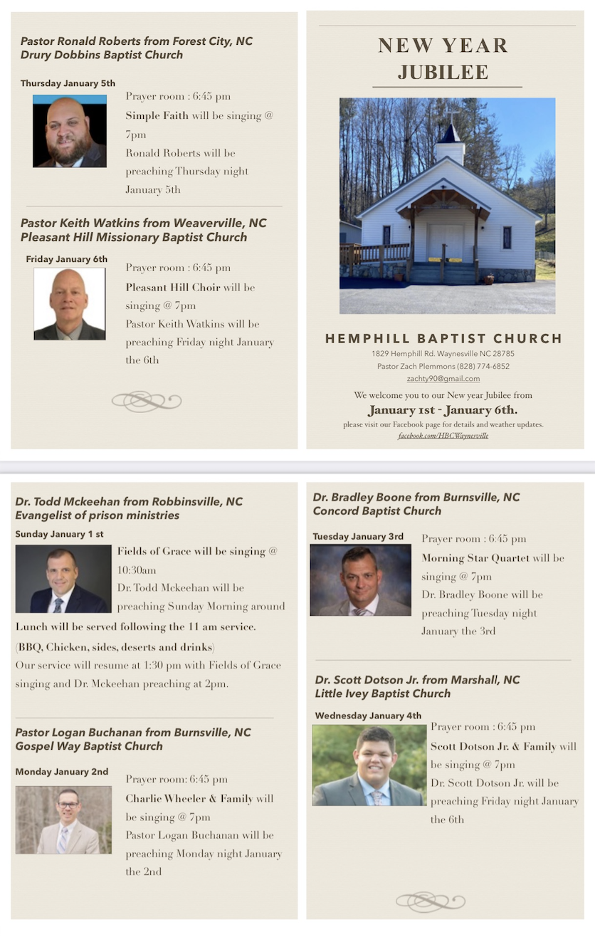

Ministry Opportunity:

There is an opportunity for Gospel ministry in our Haywood County Nursing homes. Wesley Stephens, Mission Pastor at Barberville is organizing this work. He needs volunteers who would be willing to take a turn leading worship service. His goal is to have these slots scheduled beginning with January 2023. So many of these folks are forgotten. The Lord tells us that the real religion concerns visiting the widows (James 1:27). Contact Wesley via email at: pastorwesley@barbervillebaptistchurch.org or call him at :
828-226-4491.

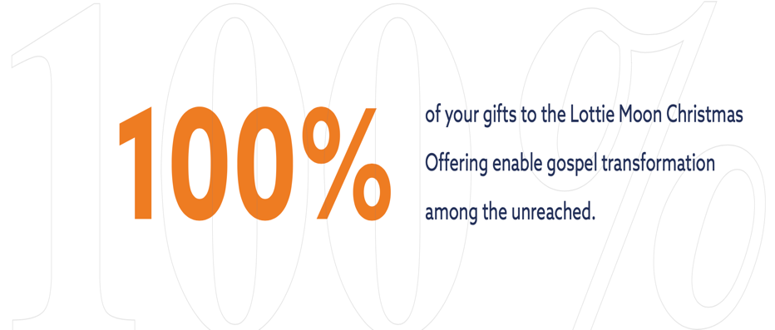

Drive Thru Live Nativity

Friday, December 16th & Saturday, December 17th
6:00PM-8:00PM
Crabtree Baptist Church
