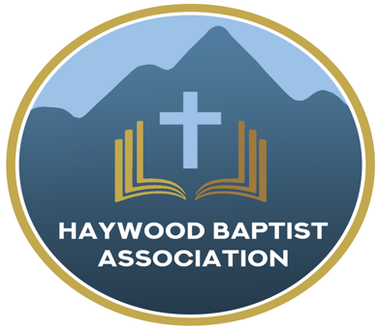
Haywood Baptist Association
Weekly E-News
January 11, 2023

AMS REPORT: 1/10/2023

Since last we met, ministry has been full-speed ahead! 2022 is done and 2023 has begun.

I continue to help Jason Miller with Bible Club at Meadowbrook Elementary School. It is challenging to work with those kiddos, but what a great opportunity. Typically, I do the Bible story with three different groups rotating through.
Woodland Baptist Church called me as their Interim Pastor. Their pastor, Josh Frazier, was called to be on staff as Missions Pastor at another of our HBA churches, The Orchard. I am working with Woodland as they search for a new pastor.

I participated in a prayer walk in Canton in response to the drug problems in that area—and in Haywood County in general. Several faith leaders were involved and we are asking God to free this community from the scourge of illegal drugs.
Dutch Cove Baptist Church gave me the opportunity to teach through the Book of Revelation on Sunday evenings. I completed that in November. The people were so gracious and attentive. If any other church would be interested in that study, or any other Bible book, I would be happy to talk to you about that.
In November, my wife and I attended our Baptist State Convention Meeting in Greensboro. It was there I was privileged to place in nomination, Pastor Jason Miller as First Vice President. I am happy to report he was elected without opposition. I also serve as the chair of the Nominating Committee of the State Convention. That report was presented and passed.

It was a joy to attend a birthday celebration for Pastor Steve Frazier. He is doing a fine job at Riverside Baptist Church and am thankful for him.

I filled in for Pastor Eddie Dietz at Mt. Zion Baptist Church for a few Sundays as he recovered from surgery. He is on the mend and back in the pulpit—thank God!
I completed the final session, “Moving Ahead Without Losing Your Head,” at the Buncombe Baptist Resource Center. Should you want to discuss the process for making needed changes in your church ministry, please give me a call.

Deacon Training continues at Clyde First Baptist Church. I have also taken Antioch through these lessons and would be happy to help your church should they desire to schedule this.
We are sad that East Waynesville Baptist Church has dissolved, yet happy to report that those facilities and assets will become the possession of Haywood Baptist Association. There are some legalities to take care of with the State government. Once that is done, we will look at a church plant being established there—a rebirth if you will. Please be in prayer for that!

The late Dr. John Tiller’s library was donated to Haywood Association. We have distributed a number of Bibles, commentaries, and books from his estate. We still have many left, if you would be interested in picking them up—free of charge!
Josh Skidmore was ordained as the new pastor of Fine’s Creek. I enjoyed taking him to lunch and am looking forward to how God is going to use him at that church.
My wife was so good at organizing a Christmas party for our ministers and wives. With our staff's help, we had a fun evening together.
Last week I was able to attend one night of Jubilee at Hemphill Baptist Church. There was a good crowd, a great spirit, and inspiring music and message. The people were so kind and along with Pastor Zach Plemmons made me feel right at home!

Now, here are some things coming up that you need to know:
- Anita Davies with NCBAM will direct Senior Adult Leader Training here at 10 AM on January 26th
- Sanctity of Life Celebration will be held at Woodland Baptist Church Sunday evening, January 29, with John Swanger, Pastor of Calvary Road preaching
- Mission Trip to Vermont led by Josh Frazier and The Orchard Church, March 3-10, contact Josh for more info. 5 spots are currently available
- Transitional Interim Pastor Training, April 24-25 at the Buncombe Baptist Resource Center
- Potential mission trip to Armenia to train local pastors, May 15-26.
In His Service,
Dennis Thurman

Our AMS Dennis Thurman is inviting everyone to
join him in prayer for our Churches and Pastors:
- Bethel- Roy Kilby
- Beulah- Barry Clark
- Burnett Siding- Donnie Buchanan

PRAY FOR UKRAINE!
Here is a prayer update from Baptists on Mission concerning Ukraine. Follow the link:
https://baptistsonmission.org/ukraine-crisis

Pastors Conference

Monday morning Pastors Conference will be starting back up on Monday, January 9th @ 10:00AM here at the Associational Office.

January speakers-
Jan. 16th- Nick Smith
Jan. 23rd- John Swanger (or another Calvary Road Pastor)
Jan. 30th- TBA

Men’s Prayer Meeting

The Men’s Prayer Group will also be starting back on Tuesday mornings at 7:00AM here at the Associational Office.

Employment Opportunities

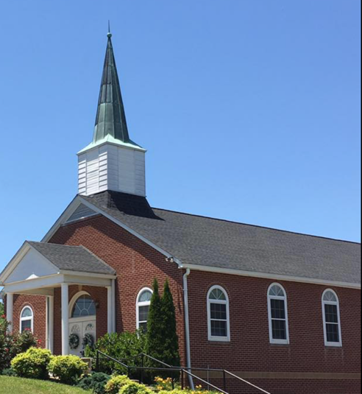
North Canton Baptist Church

North Canton Baptist Church is looking for a Song/Praise Leader. If you are interested, please contact Pastor Marty Nelson at: pastormartynelson@gmail.com

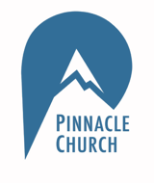
Pinnacle Church is hiring a position in student ministry. This would be to lead the middle school and high school ministries full time. For more information and to apply, please visit: https://pinnacle.elexiochms.com/external/form/34b86081-50b8-4406-9c2e-0a27bb9d37fa

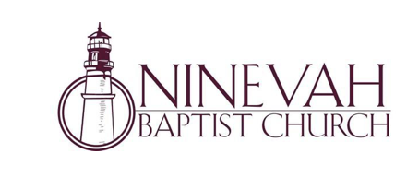
Ninevah Baptist Church is accepting resumes for a part time director of Music Ministries. If interested, please send resumes to PO Box 38. Waynesville, NC 28786

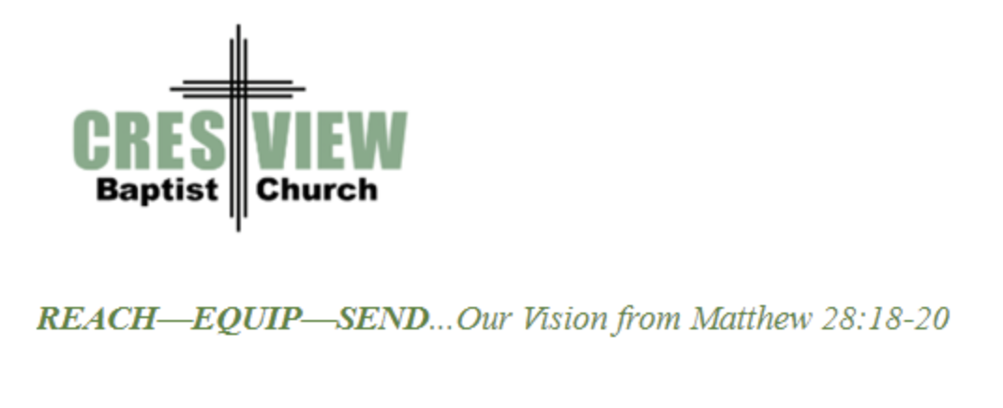
Crestview Baptist Church is now accepting resumes for a part time Worship Leader. If interested, please submit resume to 3258 Pisgah Drive Canton, NC 28716. You can also contact the church at: 828-648-1110 with any questions.

Ministry Opportunity:

There is an opportunity for Gospel ministry in our Haywood County Nursing homes. Wesley Stephens, Mission Pastor at Barberville is organizing this work. He needs volunteers who would be willing to take a turn leading worship service. His goal is to have these slots scheduled beginning with January 2023. So many of these folks are forgotten. The Lord tells us that the real religion concerns visiting the widows (James 1:27). Contact Wesley via email at: pastorwesley@barbervillebaptistchurch.org or call him at :
828-226-4491.

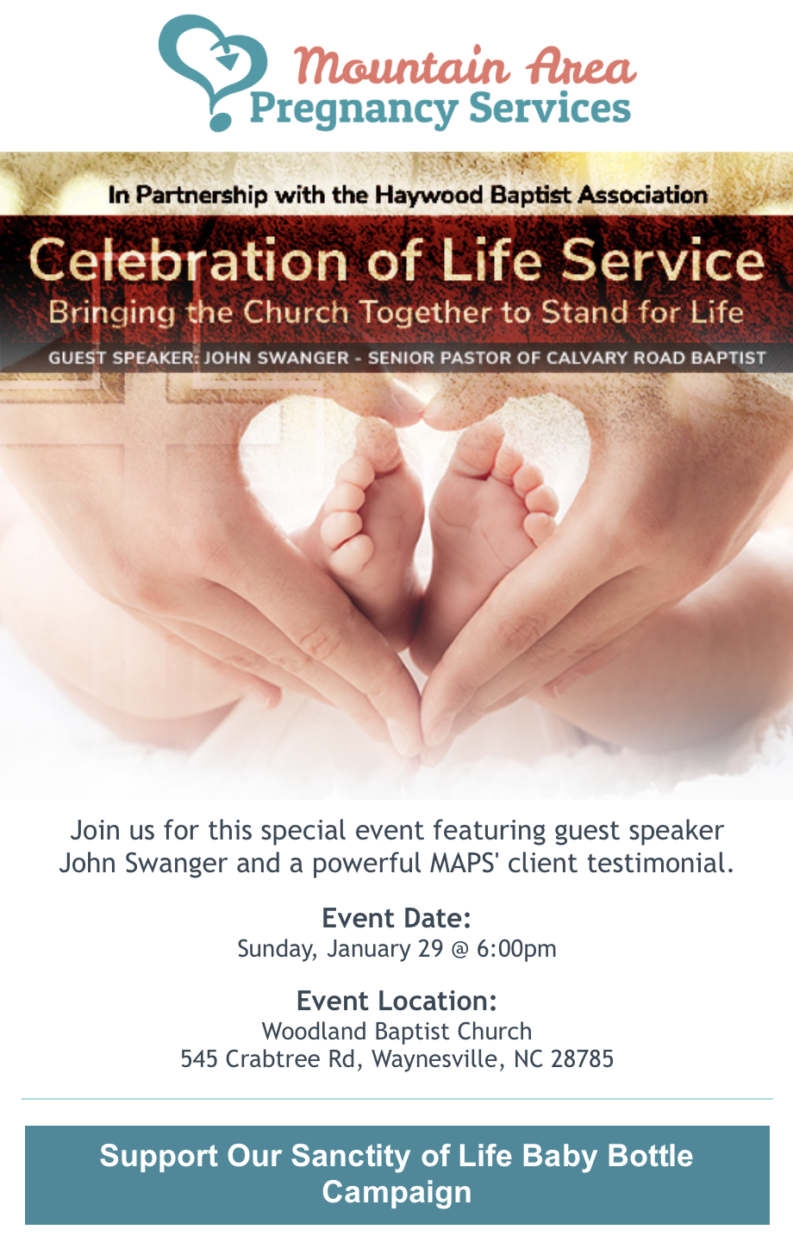

For more information, please visit:
https://theorchardnc.churchcenter.com/registrations/events/1557109

