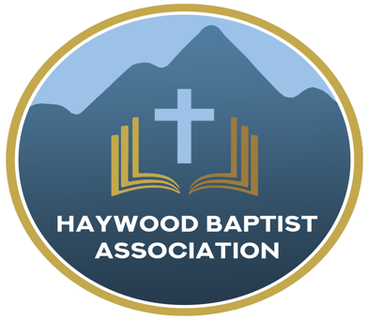
Haywood Baptist Association
Weekly E-News
December 21, 2022

THE CHRISTMAS MESSAGE FOR CONTEMPORARY MAN

“For unto you is born this day in the city of David a Savior, who is Christ the Lord.” (Luke 2:11 ESV)
Somewhere, sometime, someone first said, “Merry Christmas.” Though a familiar message, it is nevertheless a timeless truth. We can associate the word, “Merry,” with the birth of Christ for it is a message of hope that our world desperately needs to hear.
THE PEOPLE FOR WHOM CHRIST WAS BORN, “For unto you…”. Who received this message? Lowly shepherds—common folk and it is a reminder of the social status of most who respond to God’s call:
For consider your calling, brothers: not many of you were wise according to worldly standards, not many were powerful, not many were of noble birth. But God chose what is foolish in the world to shame the wise; God chose what is weak in the world to shame the strong; God chose what is low and despised in the world, even things that are not, to bring to nothing things that are, so that no human being might boast in the presence of God. And because of him you are in Christ Jesus, who became to us wisdom from God, righteousness and sanctification and redemption, so that, as it is written, “Let the one who boasts, boast in the Lord.” (1 Cor.1:26-29)
The rich often are unconcerned about eternity because they have so much on earth. That’s why Jesus said, “It is easier for a camel to go through the eye of a needle than for a rich person to enter the kingdom of God," (Mark 10:25). Yet, with God all things are possible. So it was a lady of nobility who declared she was saved by the letter “m.” Paul said not many noble, but he did not say, not any! We must admit that we are sinners who cannot save ourselves. “The saying is trustworthy and deserving of full acceptance, that Christ Jesus came into the world to save sinners, of whom I am the foremost.”(1 Tim.1:15)
THE PERIOD IN WHICH CHRIST WAS BORN, “is born this day…”. It was particularly planned in history. Gal.4:4-5 says, “But when the fullness of time had come, God sent forth his Son, born of woman, born under the law, to redeem those who were under the law, so that we might receive adoption as sons.” It was providentially planned in urgency. Three times in Hebrews 3-4, the appeal is made, “Today, if you hear his voice, do not harden your hearts…”. Then, in 2 Cor.6:2, “behold, now is the day of salvation.”

THE PLACE IN WHICH CHRIST WAS BORN, “in the city of David…”. God set the whole world in motion to fulfill a minute prophecy that the Messiah would be born in the little town of Bethlehem. It is a reminder that the promises of God are to be trusted and He can even use a pagan emperor and his system of taxation to accomplish a glorious work! We can believe all the promises of God. The prophecy of Christ’s first advent was fulfilled with precision and so will the prophecies of His second coming!
THE PURPOSE FOR WHICH CHRIST WAS BORN, “a Savior who is Christ the Lord.” Jesus came to be the Savior. Jesus Himself testified, “For the Son of Man came to seek and to save the lost.” (Luke 19:10). So that baby was born to die. The Son of God became the son of man that the sons of men might become the sons of God. Jesus came to be the Sovereign, “Christ the Lord.” Jesus came to establish the Kingdom of Heaven on earth. He will complete that task when He reigns as King of kings and Lord of Lords. We are reminded of the twofold nature of Isaiah’s prophecy in 9:6-7,

“For to us a child is born, to us a son is given; and the government shall be upon his shoulder, and his name shall be called Wonderful Counselor, Mighty God, Everlasting Father, Prince of Peace, Of the increase of his government and of peace there will be no end, on the throne of David and over his kingdom, to establish it and to uphold it with justice and with righteousness from this time forth and forevermore. The zeal of the Lord of hosts will do this.”
That speaks to the purpose of Christ's coming the first time as Savior, a Child born in Bethlehem and Son given on Calvary and His coming the second time as Sovereign to Jerusalem and "the government will be upon his shoulder."

Merry Christmas,
Dennis Thurman, AMS
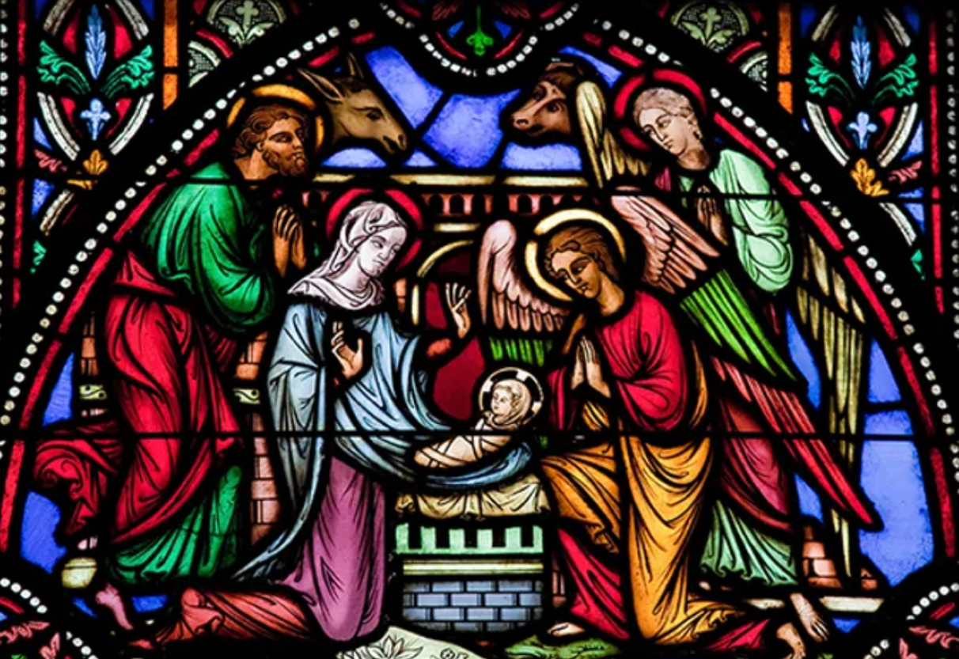

Our AMS Dennis Thurman is inviting everyone to
join him in prayer for our Churches and Pastors:
- Welcome Hill- Danny Long
- West Canton- Jeff Holder
- White Oak- Charles Shaver

PRAY FOR UKRAINE!
Here is a prayer update from Baptists on Mission concerning Ukraine. Follow the link:
https://baptistsonmission.org/ukraine-crisis

Haywood Baptist Association Holiday Schedule:

Monday, December 26th- Office CLOSED

Monday, January 2nd- Office CLOSED

Haywood Baptist Association
Quarterly Meeting

The Quarterly Meeting is coming up on Tuesday, January 10th. It will be held here at the Associational Office @ 7:00PM.

Employment Opportunities.

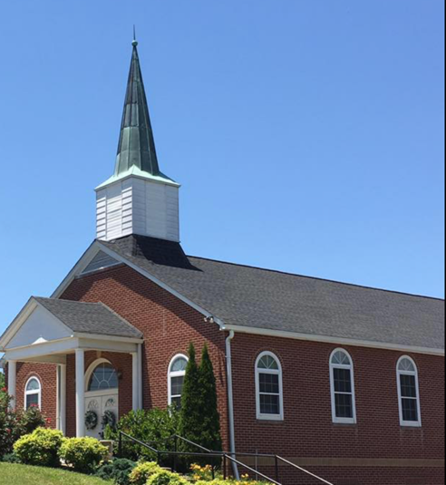
North Canton Baptist Church

North Canton Baptist Church is looking for a Song/Praise Leader. If you are interested, please contact Pastor Marty Nelson at: pastormartynelson@gmail.com

Pinnacle Church is hiring a position in student ministry. This would be to lead the middle school and high school ministries full time. For more information and to apply, please visit: https://pinnacle.elexiochms.com/external/form/34b86081-50b8-4406-9c2e-0a27bb9d37fa

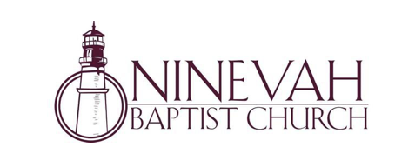
Ninevah Baptist Church is accepting resumes for a part time director of Music Ministries. If interested, please send resumes to PO Box 38. Waynesville, NC 28786

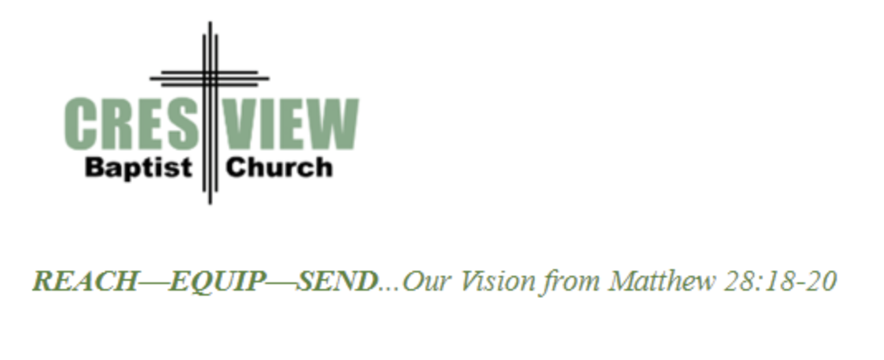
Crestview Baptist Church is now accepting resumes for a part time Worship Leader. If interested, please submit resume to 3258 Pisgah Drive Canton, NC 28716. You can also contact the church at: 828-648-1110 with any questions.

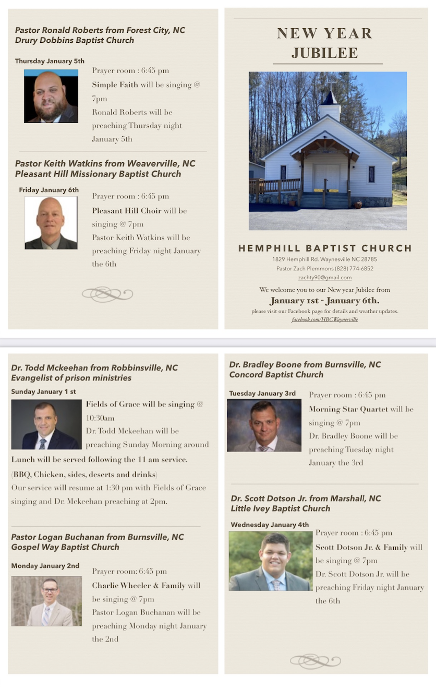

Ministry Opportunity:

There is an opportunity for Gospel ministry in our Haywood County Nursing homes. Wesley Stephens, Mission Pastor at Barberville is organizing this work. He needs volunteers who would be willing to take a turn leading worship service. His goal is to have these slots scheduled beginning with January 2023. So many of these folks are forgotten. The Lord tells us that the real religion concerns visiting the widows (James 1:27). Contact Wesley via email at: pastorwesley@barbervillebaptistchurch.org or call him at :
828-226-4491.

