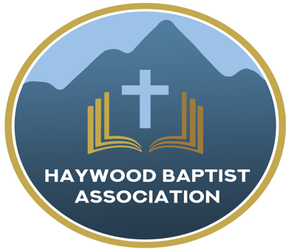
Haywood Baptist Association
Weekly E-News
February 22, 2023

REND THE HEAVENS!
Much has been said concerning revival and spiritual awakening after recent events at Asbury and other college settings. We pray that this is the beginning of another dramatic move of God. It is desperately needed. Let us pray with Isaiah:

Oh, that You would rend the heavens! That You would come down! That the mountains might shake at Your presence— 2 As fire burns brushwood, as fire causes water to boil— To make Your name known to Your adversaries, That the nations may tremble at Your presence! 3 When You did awesome things for which we did not look, you came down, the mountains shook at Your presence. 4 For since the beginning of the world Men have not heard nor perceived by the ear, nor has the eye seen any God besides You, who acts for the one who waits for Him. 5 You meet him who rejoices and does righteousness, who remembers You in Your ways. You are indeed angry, for we have sinned— In these ways we continue; And we need to be saved.
6 But we are all like an unclean thing, And all our righteousness’s are like [b]filthy rags; We all fade as a leaf, And our iniquities, like the wind, Have taken us away. 7 And there is no one who calls on Your name, who stirs himself up to take hold of You; For You have hidden Your face from us And have consumed us because of our iniquities.
8 But now, O Lord, you are our Father; We are the clay, and You, our potter; And all we are the work of Your hand. 9 Do not be furious, O Lord, nor remember iniquity forever; Indeed, please look—we all are Your people! 10 Your holy cities are a wilderness, Zion is a wilderness, Jerusalem a desolation. 11 Our holy and beautiful temple, where our fathers praised You, Is burned up with fire; And all our pleasant things are laid waste. 12 Will You restrain Yourself because of these things, O Lord? Will You hold Your peace, and afflict us very severely? (Isa.64 NKJV)

"We cannot organize revival, but we can set our sails to catch the wind from Heaven when God chooses to blow upon His people once again." (G. Campbell Morgan).

There are two ditches on either side of the road to revival. There is the ditch of dead orthodoxy. We may rightly insist on sound doctrine yet have only the form of religion while denying its power. Vance Havner stated it, "We can be straight as a gun barrel doctrinally and empty as one spiritually." The other ditch is emotional extremism. A full heart ought not to mean an empty head! Fanaticism has often distracted from a genuine move of God. The devil doesn't mind which ditch he gets you into, so long as you are stopped from spiritual progress.
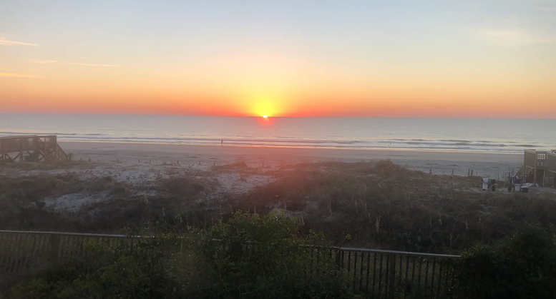
Pleading for Fresh Wind and Fire,
Dennis Thurman, Mission Strategist

Our AMS Dennis Thurman is inviting everyone to
join him in prayer for our Churches and Pastors:
- Grandview- Barry Willett
- Green Valley- Todd Cole
- Hazelwood- Tim Lolley

PRAY FOR UKRAINE!
Here is a prayer update from Baptists on Mission concerning Ukraine. Follow the link:
https://baptistsonmission.org/ukraine-crisis

Pastors Conference

Monday morning Pastors Conference are held on Monday Mornings at 10:00AM here at the Associational Office. We would love to have you join! The speaker for this upcoming Monday will be Tracy Smith, pastor of Ratcliffe Cove Baptist Church.

Men’s Prayer Meeting

The Men’s Prayer Group will meet on Saturday mornings at 7:30AM at Barberville Baptist Church. All are welcome to come!

Employment Opportunities

Pinnacle Church is hiring a position in student ministry. This would be to lead the middle school and high school ministries full time. For more information and to apply, please visit: https://pinnacle.elexiochms.com/external/form/34b86081-50b8-4406-9c2e-0a27bb9d37fa

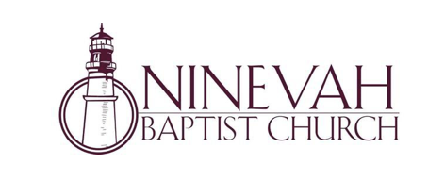
Ninevah Baptist Church is accepting resumes for a part time director of Music Ministries. If interested, please send resumes to PO Box 38. Waynesville, NC 28786

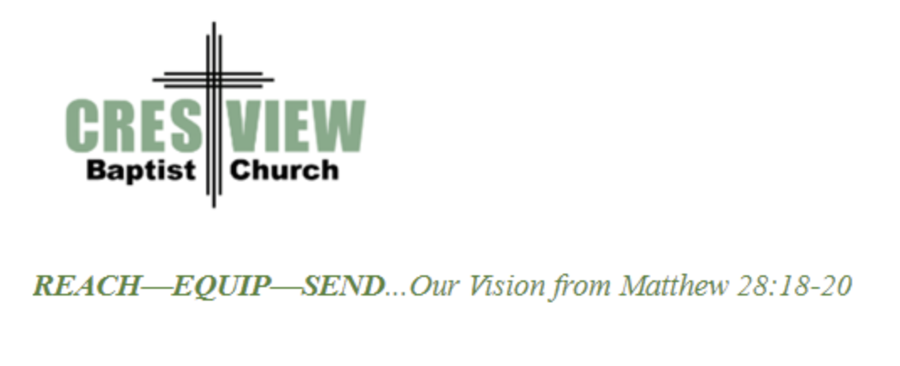
Crestview Baptist Church is now accepting resumes for a part time Worship Leader. If interested, please submit resume to 3258 Pisgah Drive Canton, NC 28716. You can also contact the church at: 828-648-1110 with any questions.

Bible Drill Info:

The Association Bible Drill will be held on Thursday, March 23rd at Mt. Zion Baptist Church. Registration is from 6:00PM-6:20PM and the drills will start at 6:30PM. If your church is planning to participate, please let Lisa Leatherwood know who passed your church drill and will advance to the association drill by Monday, March 20th. You can contact Lisa at: 828-734-3572. Thank You!

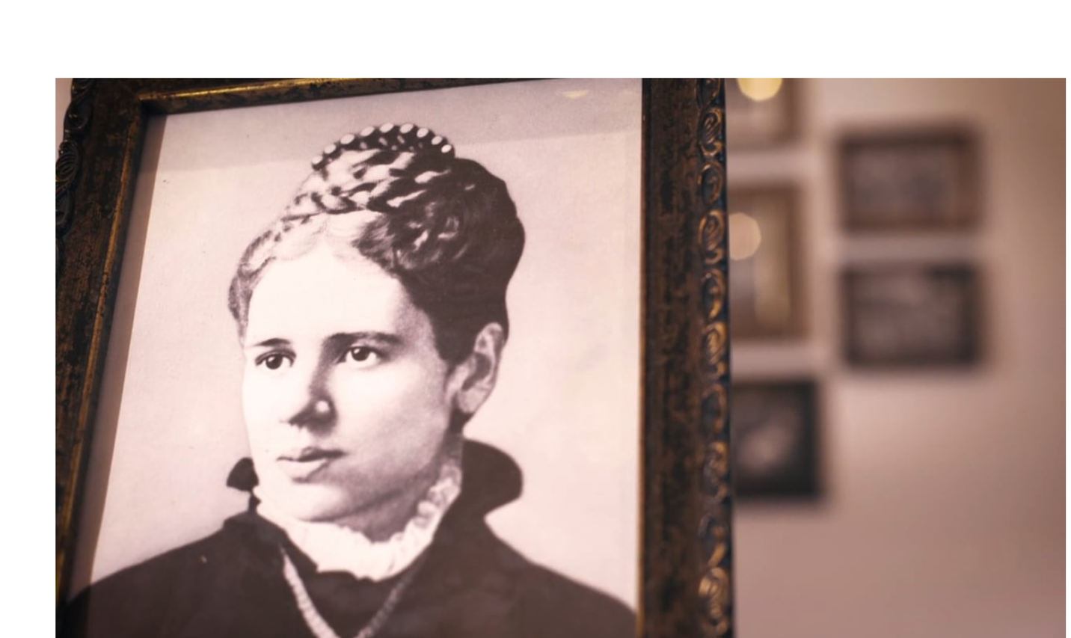

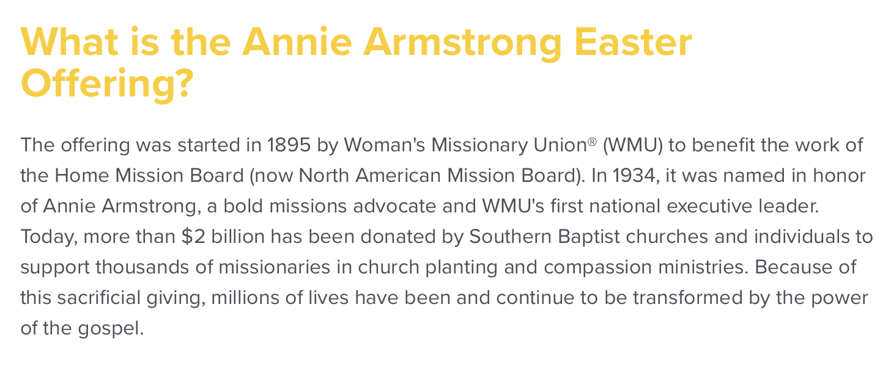

You can learn more information on the Annie Armstrong Easter Offering at:
https://www.anniearmstrong.com

