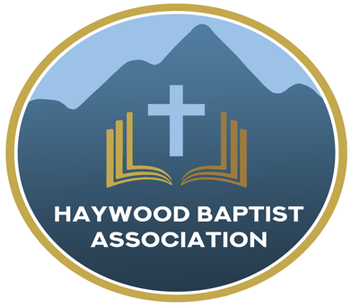
Haywood Baptist Association
Weekly E-News
January 25, 2023

CONFRONTING CHURCH CONFLICT

Church conflict is nothing new. It is not the result of polarization and politicization in 21st-century American church life. In fact, nearly as soon as the church was birthed, growing pains arrived (see Acts 6).

In one sense, church conflict is not bad and is inevitable. Think of it as an opportunity to improve your relationships with others. As your nervous system enables you to feel the pain to protect your health, so the health of the fellowship in the church is enhanced when we feel the pain of conflict--that is if we seek the Great Physician for the cure. Cancer moves from treatable to terminal if warning signs are neglected. Is your church family having some squabbles? You ignore it to the peril of the local body of believers.

Sometimes an arbiter can be used to help the conflict be resolved in a productive way. I would be grateful to be used of God, should you think that helpful. Yet, I can only be a tool--it is the hands of God that must bring healing.

We are hearing of more and more conflict in churches and those who have been for some time having a family feud are finding it intensifying. I am praying for forgiveness and reconciliation among our churches. Conflict will come sooner or later. The crucial question is will you confront it? Or will you ignore it and hope it goes away on its own? Maybe you will go to war and try to beat down the opposition or run them off. Neither approach--flight or fight--is God's way.
Praying for Unity,
Dennis Thurman, AMS

Our AMS Dennis Thurman is inviting everyone to
join him in prayer for our Churches and Pastors:
- Canton First- Court Greene
- Clyde First- Byron Burnette
- Cove Creek- Isaac Brooks

PRAY FOR UKRAINE!
Here is a prayer update from Baptists on Mission concerning Ukraine. Follow the link:
https://baptistsonmission.org/ukraine-crisis

Pastors Conference

Monday morning Pastors Conference are held on Monday Mornings at 10:00AM here at the Associational Office. We would love to have you join!

Men’s Prayer Meeting

The Men’s Prayer Group will meet on Tuesday’s at 8:00AM at Barberville Baptist Church.

Employment Opportunities

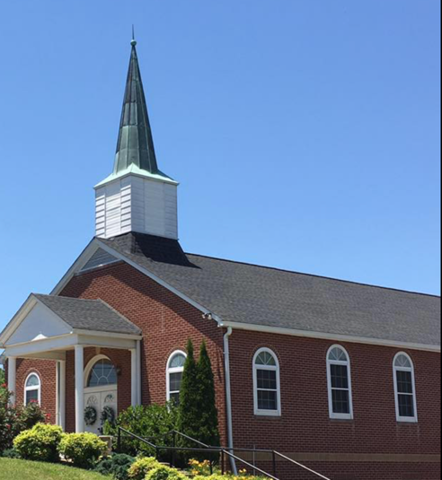
North Canton Baptist Church

North Canton Baptist Church is looking for a Song/Praise Leader. If you are interested, please contact Pastor Marty Nelson at: pastormartynelson@gmail.com

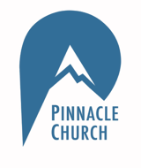
Pinnacle Church is hiring a position in student ministry. This would be to lead the middle school and high school ministries full time. For more information and to apply, please visit: https://pinnacle.elexiochms.com/external/form/34b86081-50b8-4406-9c2e-0a27bb9d37fa

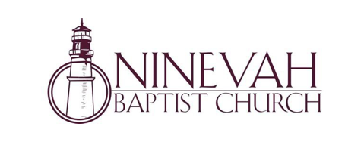
Ninevah Baptist Church is accepting resumes for a part time director of Music Ministries. If interested, please send resumes to PO Box 38. Waynesville, NC 28786

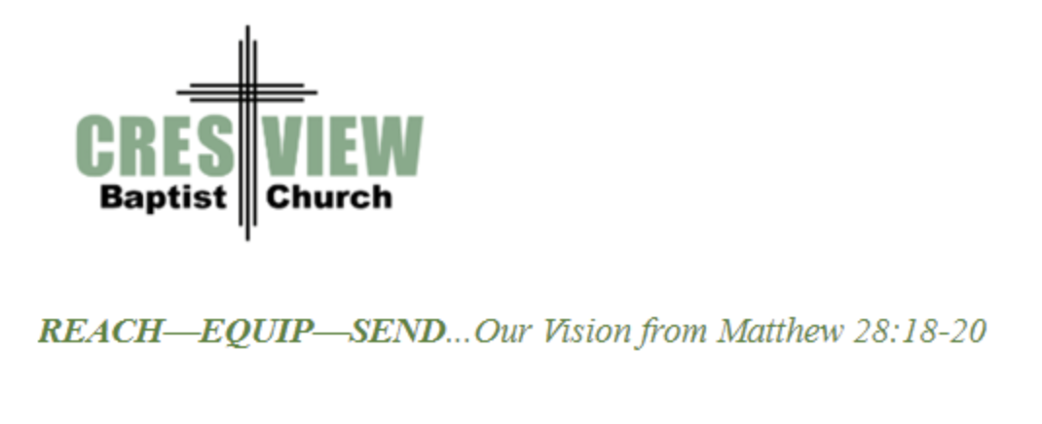
Crestview Baptist Church is now accepting resumes for a part time Worship Leader. If interested, please submit resume to 3258 Pisgah Drive Canton, NC 28716. You can also contact the church at: 828-648-1110 with any questions.

Ministry Opportunity:

There is an opportunity for Gospel ministry in our Haywood County Nursing homes. Wesley Stephens, Mission Pastor at Barberville is organizing this work. He needs volunteers who would be willing to take a turn leading worship service. His goal is to have these slots scheduled beginning with January 2023. So many of these folks are forgotten. The Lord tells us that the real religion concerns visiting the widows (James 1:27). Contact Wesley via email at: pastorwesley@barbervillebaptistchurch.org or call him at :
828-226-4491.

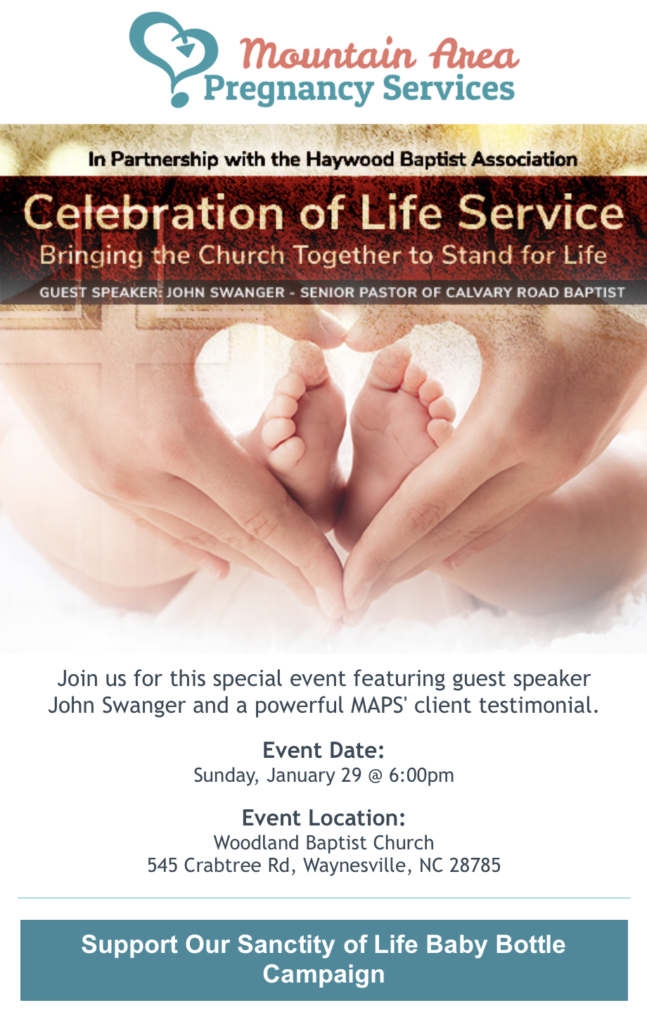

For Those Who Care About Senior Adult Ministry

Join pastors and senior adult leaders within the Haywood Baptist Association to explore Senior Adult Ministry in our churches. Especially if you are a pastor without a senior adult ministry, we hope you will come or ask a leader in your church to attend.

Thursday, January 26
10:00 am
Haywood Baptist Association Office

We’ll come together to:
- Share what is working well in our senior adult ministries
- Take away new ministry ideas for serving seniors and for seniors to serve others
- Learn ways NC Baptist Aging Ministry can help start or enhance senior adult ministries in our churches and community
- Explore effective strategies for in-reach and outreach

Anita Davie, NCBAM’s far west regional director, will share tools available from NCBAM to help strengthen your senior adult ministries. Anita believes God has an important job for each of us—no matter our age or situations.

North Carolina Baptist Aging Ministry (NCBAM) is administered by the Baptist Children’s Home of North Carolina. NCBAM’s mission is to provide “Help for the Journey” to seniors in ways that help them maintain their independence and quality of life—including spiritual aspects. NCBAM has received 41 state and national awards including Innovative Program Award and the prestigious Religion, Spirituality and Aging Award.

A church within our Association, Laurel Grove Baptist Church is having a difficult time financially. If anyone would like to send a monetary donation, you can do so by mailing to the church address:
Laurel Grove Baptist Church
83 School House Branch Rd.
Canton, NC 28716.

If you have any questions, please contact the pastor of Laurel Grove- Gary Putnam at:
828-734-7197.

You can also send donations to the Association Office, and we will get it to the church.

Thank you!

