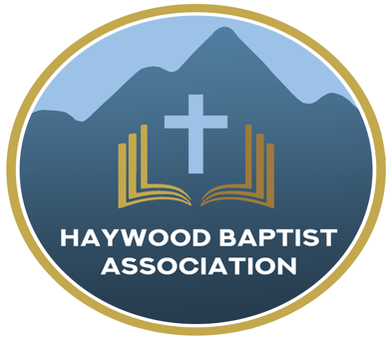
Haywood Baptist Association
Weekly E-News
October 26, 2022

ASSOCIATIONAL MISSION STRATEGIST REPORT

Since our last meeting, I began a four part monthly series meeting at the Buncombe Baptist Resource Center that I call, “Moving Ahead Without Losing Your Head!” In this we discuss transitions that are important for progress in the church, while dealing with the inevitable challenges that come with change. I will finish that study this month and would be happy to share it with our association if there is interest.

Marilyn and I were blessed to worship with Nineveh Baptist Church on Sunday morning, August 14. We also attended Decoration and enjoyed a delicious meal and sweet fellowship with White Oak Baptist Church and attended Homecoming at James Chapel. A Day of Remembrance was observed at East Fork as they remembered those who died in the flood a year ago. It was an emotional and encouraging time with this community. In addition I preached at Beulah Baptist, Antioch, Calvary, High Street, and Lake Junaluska First. Additionally, I have led a study of the Book of Revelation at Dutch Cove on Sunday evenings and have led Wednesday night Bible Study at Crestview on two occasions. I also preached a revival service at Clyde First. My wife and I took a trip to the Creation Museum and the Ark Encounter. I would encourage anyone to go see these powerful displays. I led a Sunday School Rally at Crestview Baptist Church. If any of our churches would like help with their Sunday School, please call me! I attended each night of the Pisgah Camp Meeting and was edified by the strong preaching. Deacon Training is also something I can do, and I am currently working with Clyde First Baptist deacons. Dellwood had a Man Up Conference with former professional wrestler, Ivan Kolloff, which I was able to attend on the first night.

I spoke with several of our pastors who are facing some discouraging times in ministry. The challenges are immense and the Devil is at work. October is Pastor Appreciation Month. A number of our churches have observed this—you ought to! It is not too late, if you have not.

I finished my Pastoral Counseling class I teach at Fruitland Baptist Bible College. It has been a joy to work with these young students preparing for ministry. I met with a young man from Barberville who was encouraged to follow his call to ministry by enrolling at Fruitland. He did! Additionally, I am Ministry Supervisor for Pole Creek’s Pastor, Ben Heise, as he studies with Gateway Seminary. Should any of our pastors desire mentoring, I would count it a privilege to work with them.

On the mission front, we set up for Canton’s Labor Day Festival and ministered there. Despite the pouring rain, we shared the Gospel and one teenage girl prayed to be saved. I attended the Western Area Conference at Broyhill Baptist Children’s Home. My wife and I worked the break tent for workers at the Mountain State Fair, sharing the love of Christ. Bible Club resumed and I am working with Pastor Jason Miller at Meadowbrook School on Tuesday afternoons. I travelled to Franklin and spoke at Men’s Teen Challenge chapel service for those who are there seeking freedom from addiction. Recently, my wife has been able to visit with Mountain Area Pregnancy Services new office in Waynesville and we both attended MAPS Gala Fundraiser in Asheville. It is a ministry that is making a difference!

I am planning on traveling to southwest Florida to do disaster relief the first week of December. Take a look at your calendar and see if that is a possibility for you. The need there is great and there is an open door to share the Gospel. Next year we hope to return to Vermont in early summer and also take an international trip early fall. Details will be forthcoming. Be in prayer for that!

Thank you for your partnership in the Gospel!

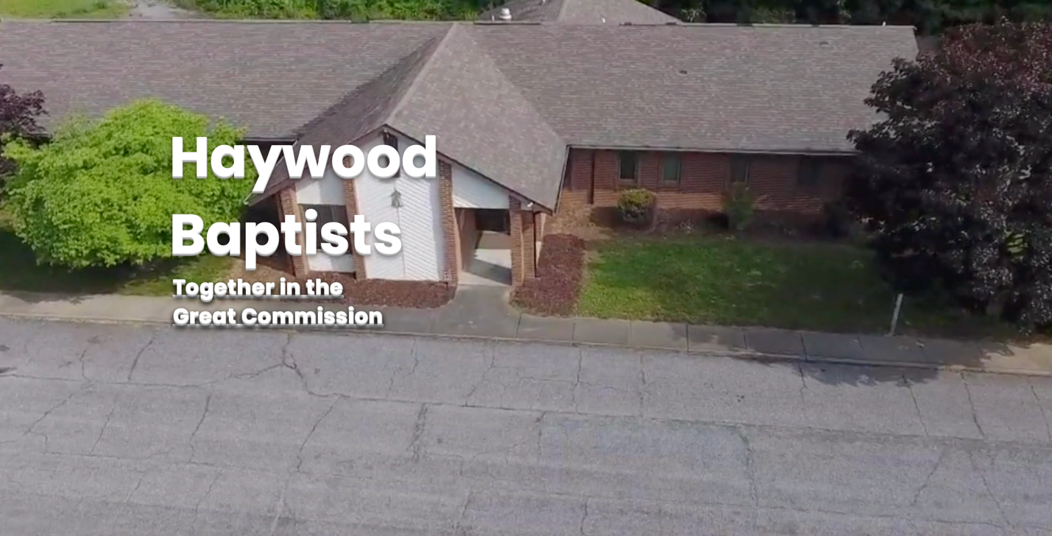

Our AMS Dennis Thurman is inviting everyone to
join him in prayer for our Churches and Pastors:
- Hemphill- Zachary Plemmons
- High Street- Chris Willett
- Casa De Dios- Robert Fernandez

PRAY FOR UKRAINE!

Here is a prayer update from Baptists on Mission concerning Ukraine. Follow the link:
https://baptistsonmission.org/ukraine-crisis

MEN’S PRAYER MEETING
We have a prayer meeting at the Associational Office at 7 AM Tuesdays for a time of focused prayer. Pastors, staff, and other men are invited. We will pray for the churches, we will pray through Scripture texts that and asking for God to guide our ministry for the week and bring anointing in our messages, music, and mission.

Hurricane Ian Updates

Here is a video link, you might want to share with your congregation:

https://vimeo.com/755769951

This is an update from Baptists On Mission:

https://baptistsonmission.org/Mission-Projects/By-Mission-Type/Disaster-Relief/Hurricane-Ian

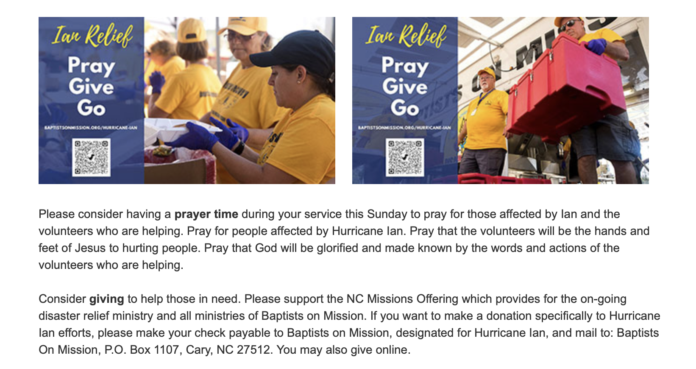

Employment Opportunities.

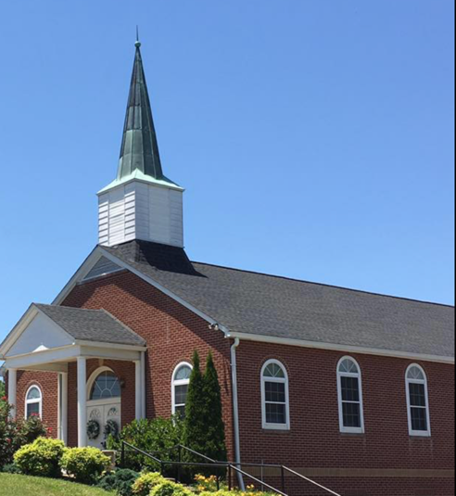
North Canton Baptist Church

North Canton Baptist Church is looking for a Song/Praise Leader. If you are interested, please contact Pastor Marty Nelson at: pastormartynelson@gmail.com

Pinnacle Church is hiring a position in student ministry. This would be to lead the middle school and high school ministries full time. For more information and to apply, please visit: https://pinnacle.elexiochms.com/external/form/34b86081-50b8-4406-9c2e-0a27bb9d37fa

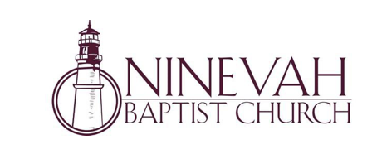

Ninevah Baptist Church is accepting resumes for a part time director of Music Ministries. If interested, please send resumes to PO Box 38. Waynesville, NC 28786.

The Haywood County Bible Clubs will soon be meeting in our elementary schools.
We have seen God's hand working in many children's lives and the lives of the families. Consider supporting the clubs by volunteering to help, donating prepackaged snacks, becoming a prayer partner: there are many ways to serve! Please contact Charles and Barbara Biera for more information. 828-421-0811
Bethel Elementary Club needs leaders/helpers- the club meets on Thursday afternoons Please call Amy Warren 828-246-2732

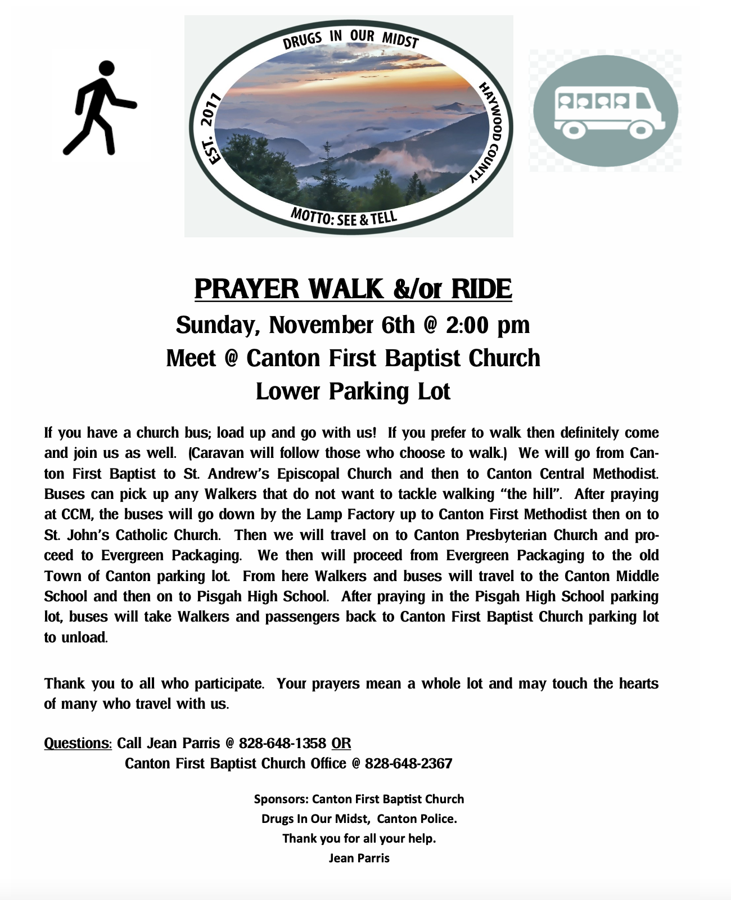
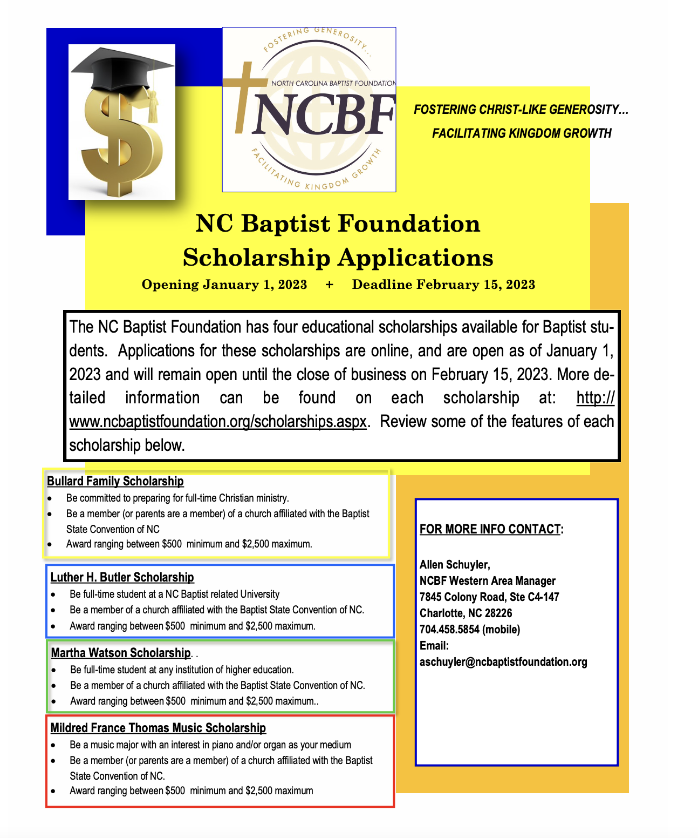

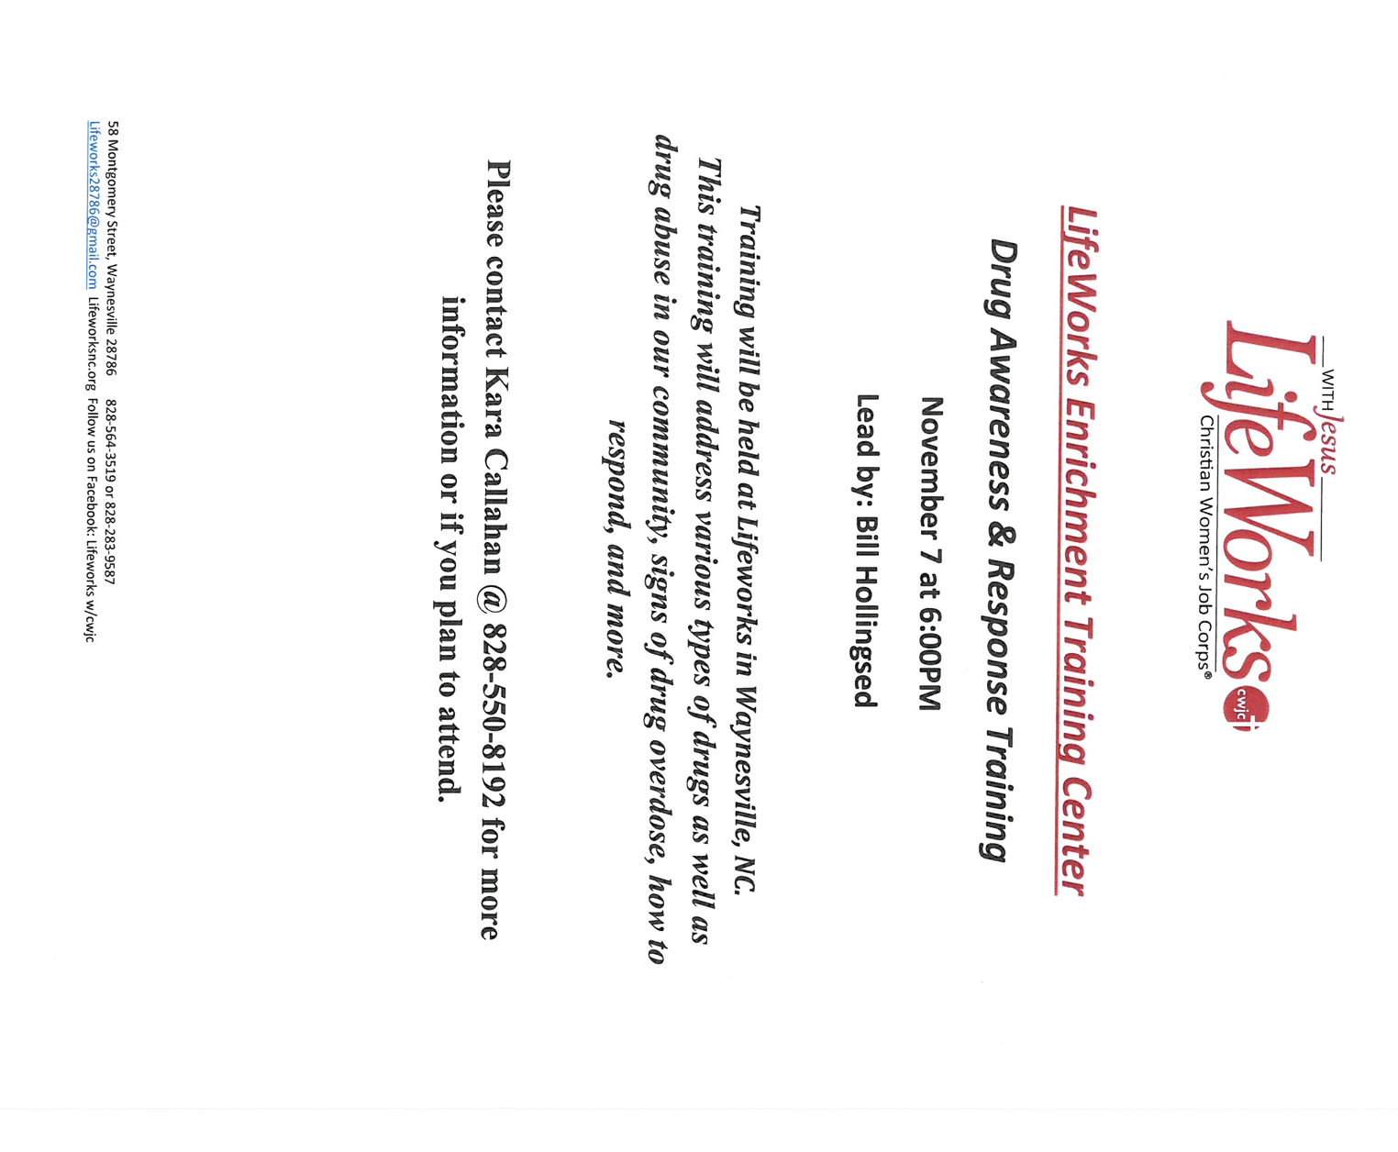

This event will be at Canton First Baptist Church.

