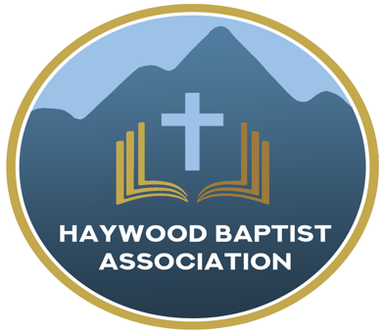
Haywood Baptist Association
Weekly E-News
December 28, 2022

I AM RESOLVED

New Year's resolutions are often mocked. I understand. We frequently are quick to express our intention without true dedication. When all is said and done, there is more said than done.

Yet, the truth is we seldom do anything of value unless there is a resolution to do so. Here are the resolutions of a godly man, Jonathan Edwards:
https://www.desiringgod.org/articles/the-resolutions-of-jonathan-edwards

Edwards was not a perfect man--none are, save Jesus Christ. Yet, by aiming at these lofty goals, he was closer to hitting the target, than if he had aimed at nothing. If you aim at nothing, you will hit it every time!
Whether you adopt Edwards' resolutions or adapt your own, let us pray that by the grace of God, we will move forward in faith this year. We cannot rewind 2022, but we can pray to see God do a deeper work in us and a wider work through us in 2023. That is my prayer!

Happy New Year,
Dennis Thurman, AMS

Our AMS Dennis Thurman is inviting everyone to
join him in prayer for our Churches and Pastors:
- Woodland- Dennis Thurman (Interim)
- Allen’s Creek- Scotty Patrick
- Antioch- Chris Wilmoth

PRAY FOR UKRAINE!
Here is a prayer update from Baptists on Mission concerning Ukraine. Follow the link:
https://baptistsonmission.org/ukraine-crisis

Haywood Baptist Association Holiday Schedule:

Monday, January 2nd- Office CLOSED

Haywood Baptist Association
Quarterly Meeting

The Quarterly Meeting is coming up on Tuesday, January 10th. It will be held here at the Associational Office @ 7:00PM.

Employment Opportunities.

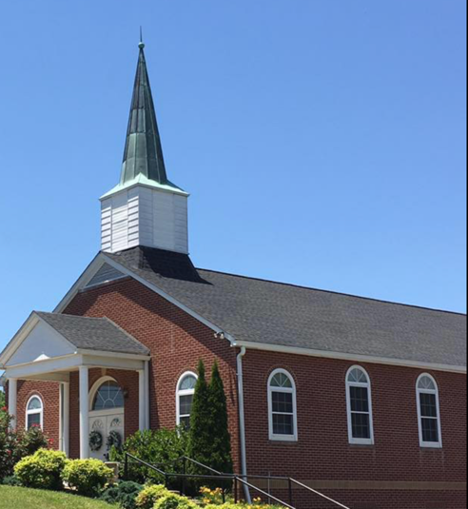
North Canton Baptist Church

North Canton Baptist Church is looking for a Song/Praise Leader. If you are interested, please contact Pastor Marty Nelson at: pastormartynelson@gmail.com

Pinnacle Church is hiring a position in student ministry. This would be to lead the middle school and high school ministries full time. For more information and to apply, please visit: https://pinnacle.elexiochms.com/external/form/34b86081-50b8-4406-9c2e-0a27bb9d37fa

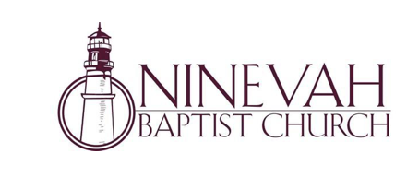
Ninevah Baptist Church is accepting resumes for a part time director of Music Ministries. If interested, please send resumes to PO Box 38. Waynesville, NC 28786

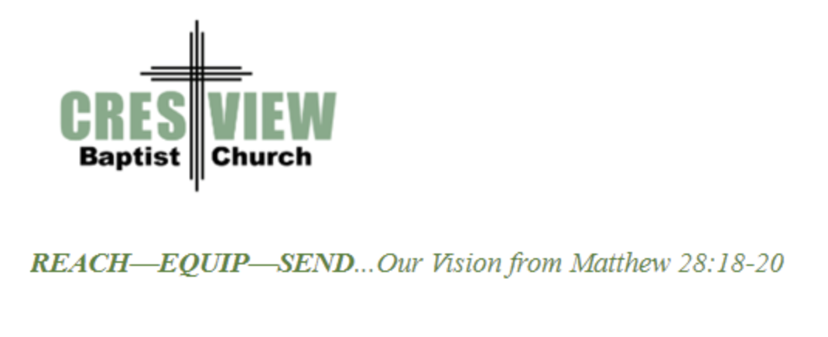
Crestview Baptist Church is now accepting resumes for a part time Worship Leader. If interested, please submit resume to 3258 Pisgah Drive Canton, NC 28716. You can also contact the church at: 828-648-1110 with any questions.

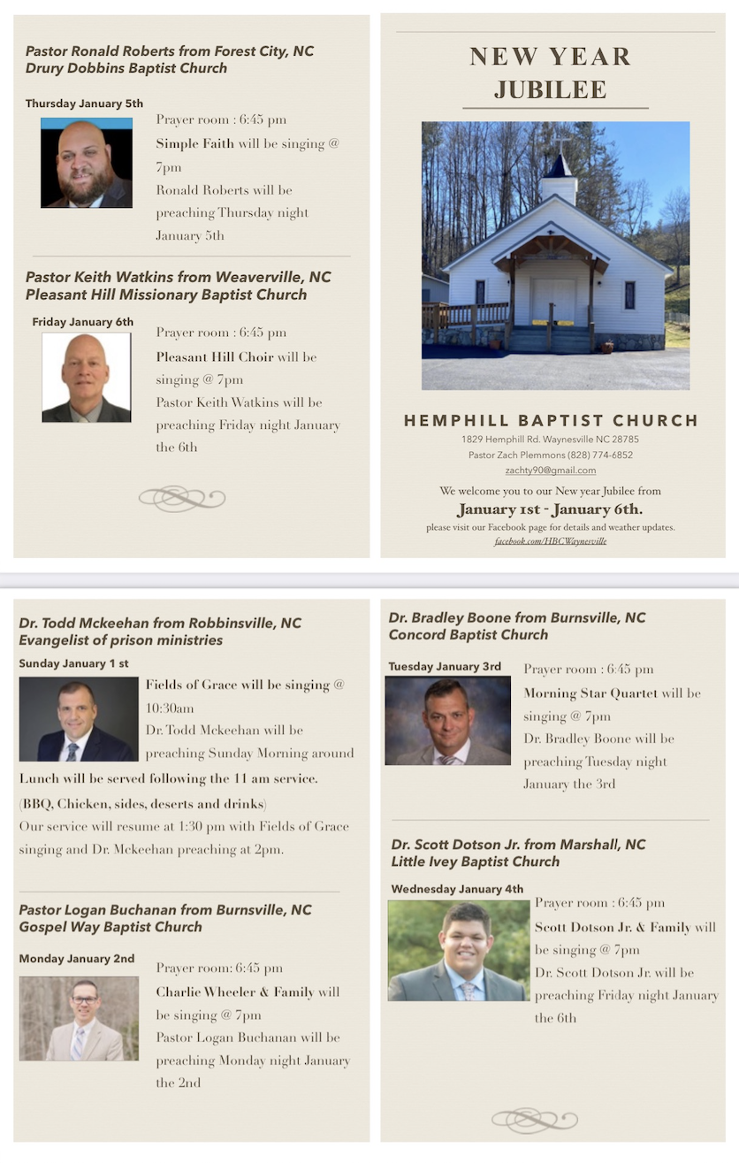

Ministry Opportunity:

There is an opportunity for Gospel ministry in our Haywood County Nursing homes. Wesley Stephens, Mission Pastor at Barberville is organizing this work. He needs volunteers who would be willing to take a turn leading worship service. His goal is to have these slots scheduled beginning with January 2023. So many of these folks are forgotten. The Lord tells us that the real religion concerns visiting the widows (James 1:27). Contact Wesley via email at: pastorwesley@barbervillebaptistchurch.org or call him at :
828-226-4491.

