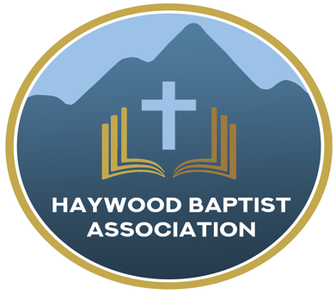
Haywood Baptist Association
Weekly E-News
November 2, 2022

CHANGE OF TIME AND TIME OF CHANGE

So, this Lord's Day brings one of the favorite times on the church calendar--time change! We gain an hour of sleep and that usually yields a gain in attendance. Also, there is generally less grumpiness and more gladness reflected on Baptist faces. Winner, winner, chicken dinner!!! So, remember to have your members turn their clocks back an hour when they go to bed this Saturday night.
Speaking of a change of time, we as a church face time of change. Things are not how they used to be and are not likely to ever go back. Change is occurring at an exponential rate. That is hard. Usually, the only ones who like change are babies--and they cry about it! Sadly, one of the worst things about the cultural earthquake that is shaking our world, is that the world seems to be impacting the church much more than the church is impacting the world! That needs to change!
What would be a significant change in your life spiritually that would help you become more like Jesus? What is one change that your church might make that would make the biggest difference in enabling the church to glorify God in a greater way? Progress requires movement. Henry Blackaby put it, "You cannot stay where you are and go with God." He added, "Look to see where God is working and join Him in His work!" Wise words.

Thank God that in these turbulent times, we can look to an unchanging God--to Jesus Christ, the same yesterday, today, and forever! We have a Book that is immutable, eternally relevant, with the 2000-year-old Gospel that still changes lives! That is what He desires to do in me and you and through us as His people.
Yours for Growing in Christ,
Dennis Thurman, AMS

Our AMS Dennis Thurman is inviting everyone to
join him in prayer for our Churches and Pastors:
- James Chapel- Jeff Moore
- Jonathan Valley- Billy Ferguson
- FBC Lake Junaluska- Nick Smith

PRAY FOR UKRAINE!

Here is a prayer update from Baptists on Mission concerning Ukraine. Follow the link:
https://baptistsonmission.org/ukraine-crisis

MEN’S PRAYER MEETING
We have a prayer meeting at the Associational Office at 7 AM Tuesdays for a time of focused prayer. Pastors, staff, and other men are invited. We will pray for the churches, we will pray through Scripture texts that and asking for God to guide our ministry for the week and bring anointing in our messages, music, and mission.

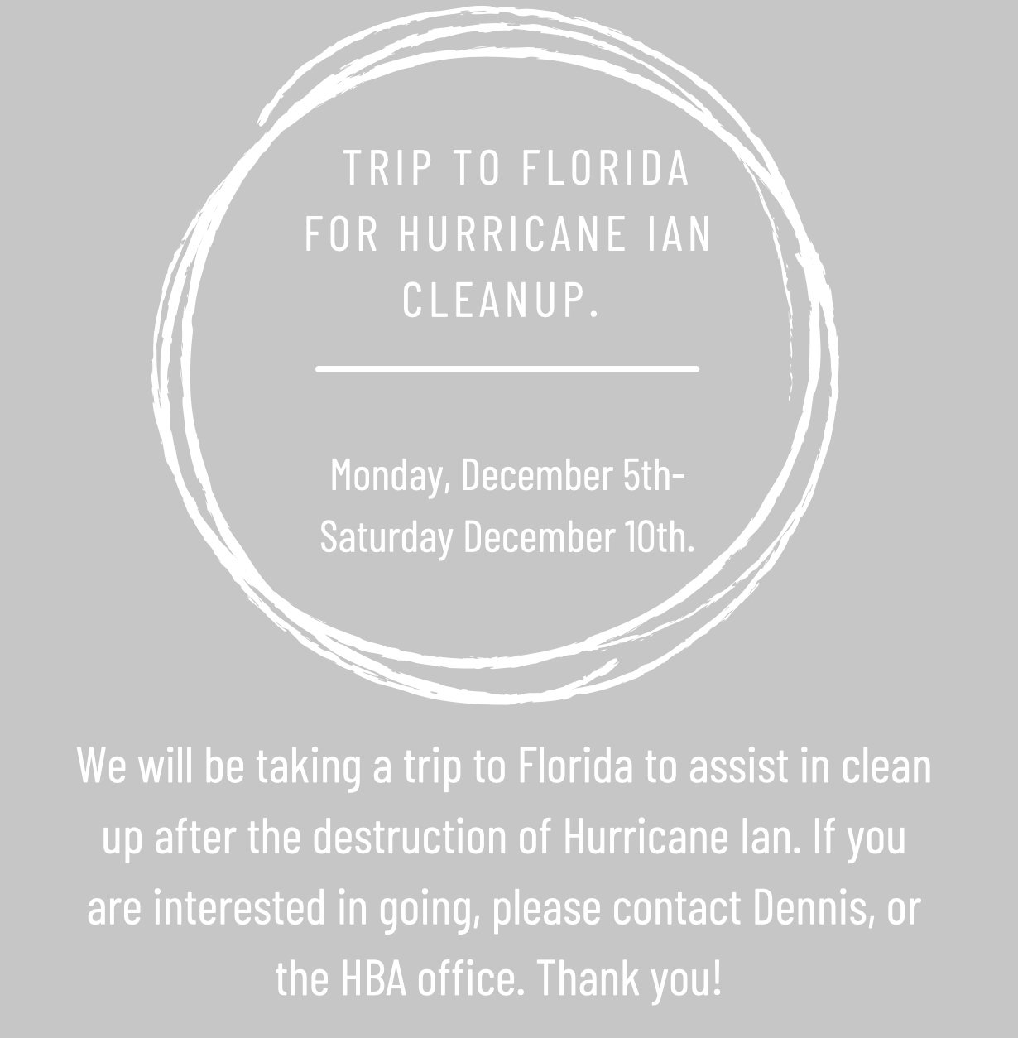

Employment Opportunities.

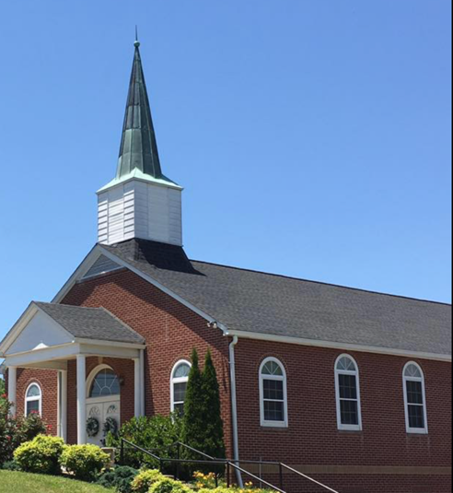
North Canton Baptist Church

North Canton Baptist Church is looking for a Song/Praise Leader. If you are interested, please contact Pastor Marty Nelson at: pastormartynelson@gmail.com

Pinnacle Church is hiring a position in student ministry. This would be to lead the middle school and high school ministries full time. For more information and to apply, please visit: https://pinnacle.elexiochms.com/external/form/34b86081-50b8-4406-9c2e-0a27bb9d37fa

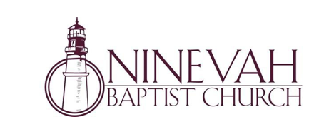

Ninevah Baptist Church is accepting resumes for a part time director of Music Ministries. If interested, please send resumes to PO Box 38. Waynesville, NC 28786.

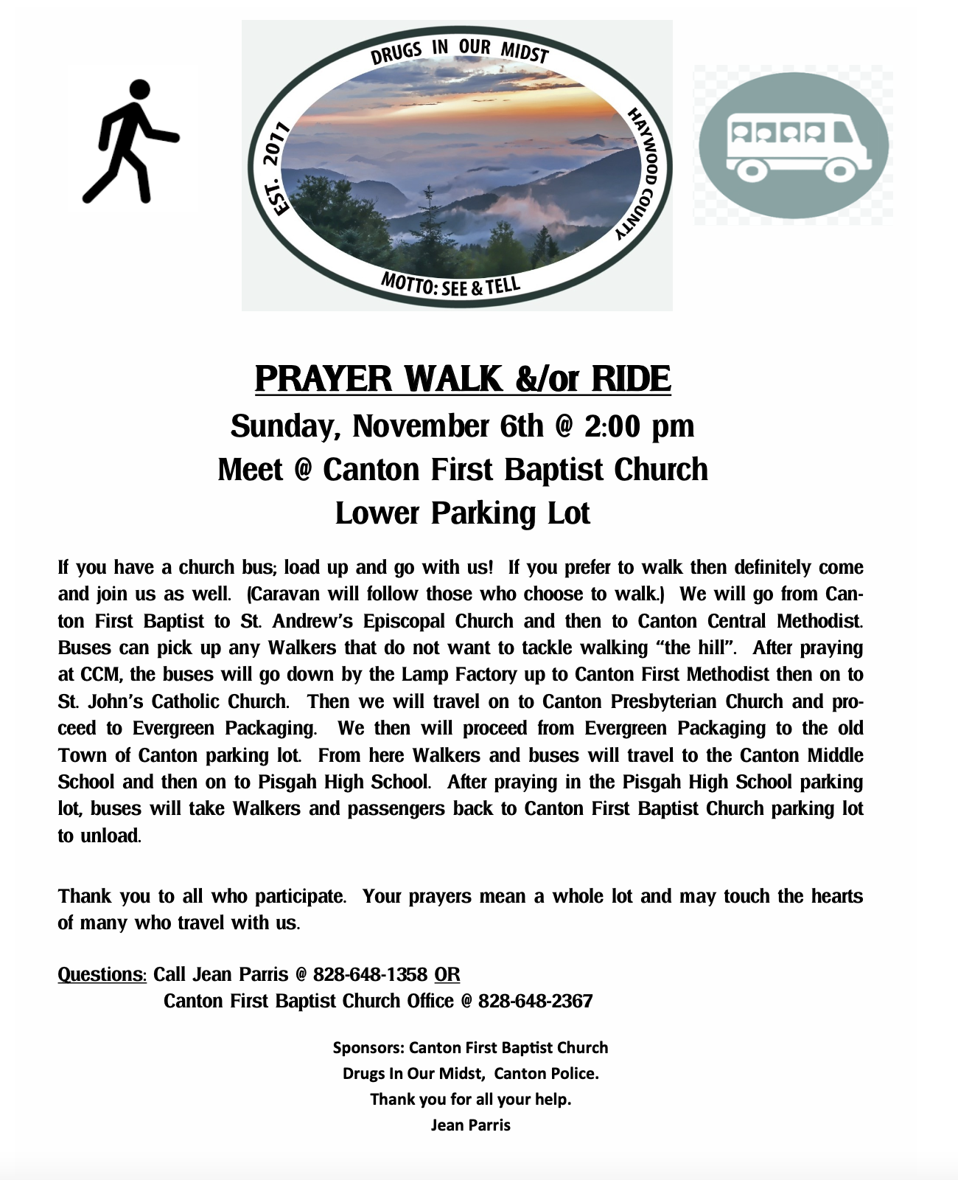

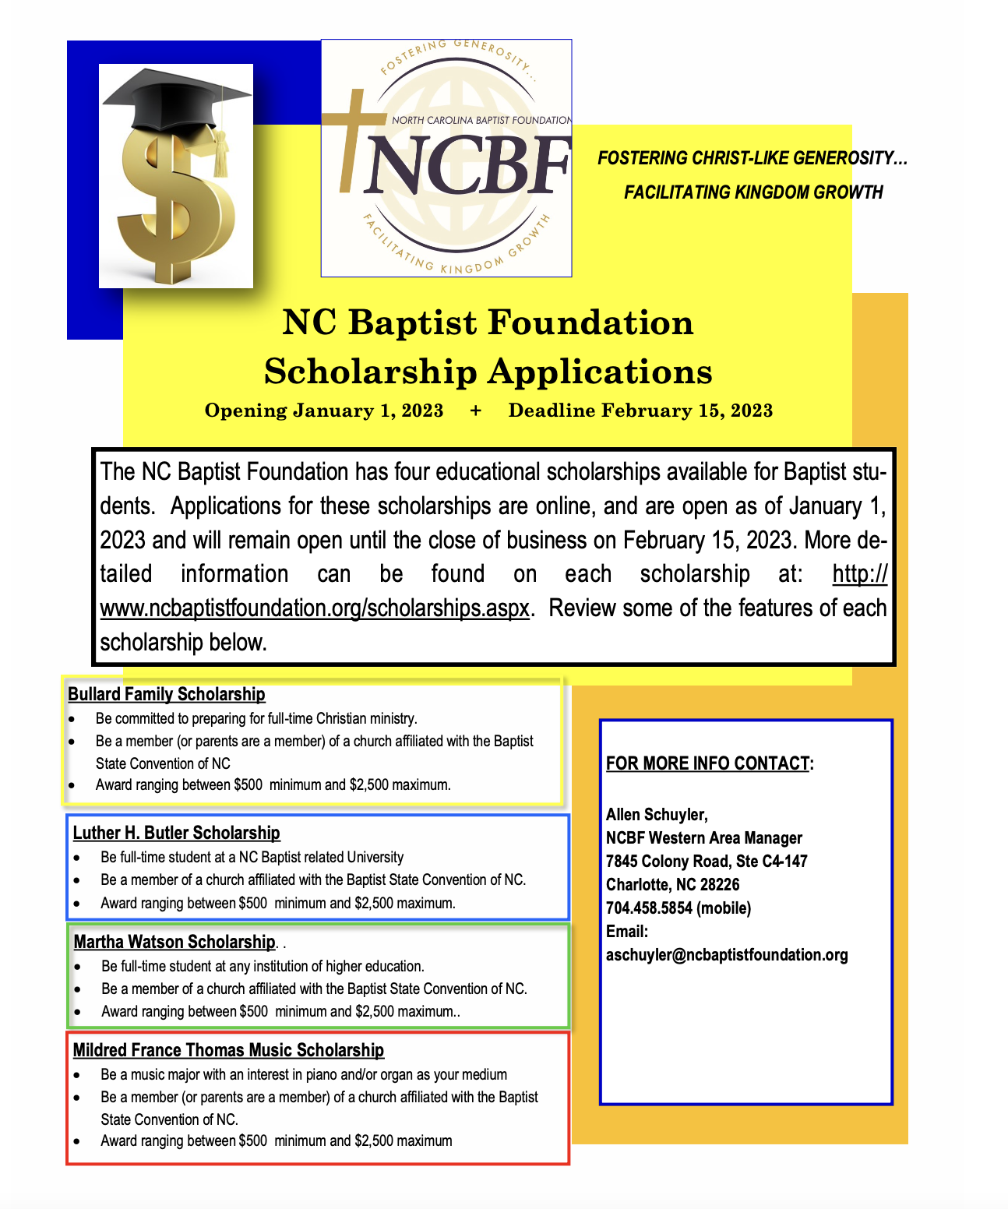

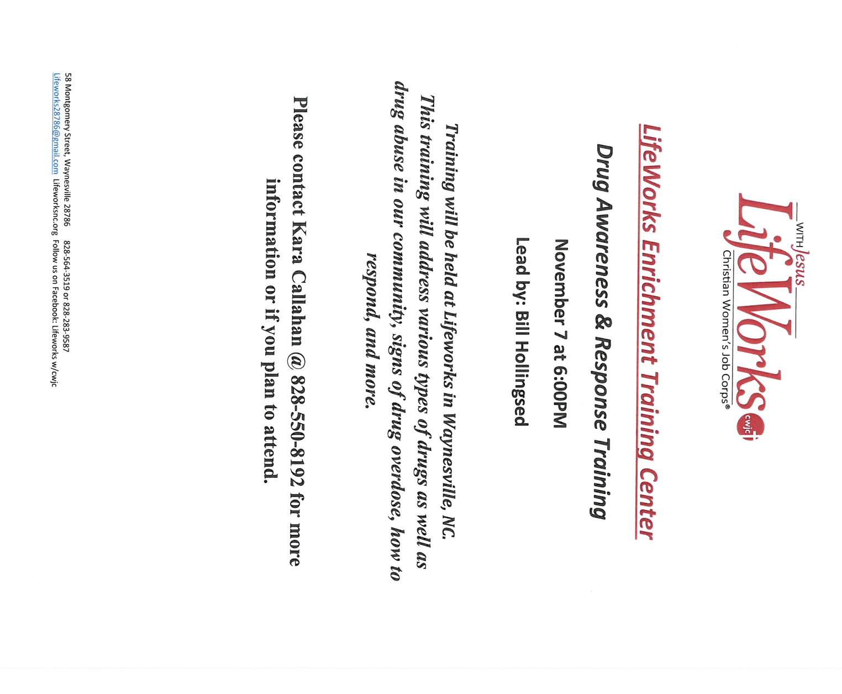

This event will be at Canton First Baptist Church.

