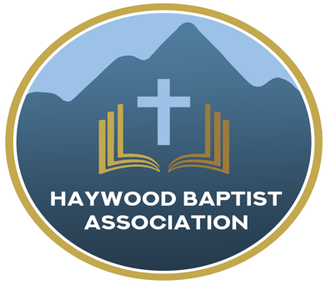
Haywood Baptist Association
Weekly E-News
March 29, 2023

Heartache and Hope

In the wake of the brutal murders in Nashville at the Covenant Christian school, we join in sharing the tears and travail of all who faced such terror. Our prayers go out to the Pastor and his wife whose little girl was among the dead. What heartache! Yet, because of the death of Jesus and His resurrection victory, death has been defeated. Those who died in faith in Christ are safely home and gladness will overcome sadness on that great reunion day.
We pray for all those who grieve. Yet, our hearts should also ache for this nation that seems caught in the death throes of a society. We are seeing our country's moral and religious fabric unraveling before our eyes. Still, we have some hope. Nineveh was one of the most demonic, perverse, and violent cities ever. The Assyrians were bloodthirsty. What hope is there for people like that? Jonah preached and a spiritual awakening came. The people repented and God relented of the judgment He intended. If it could happen to Nineveh, the possibility is that the same God could do this for America! Let us pray so!

Ultimately, Nineveh would return to its evil and God would judge them, as recorded in Nahum. The heartbreaking reality is that this world is bound for judgment--America included. Yet, the darkest hour will be just before dawn. The blessed hope is in the second coming of Jesus Christ. Inexorably and invincibly His will shall be done on earth as it is in heaven!

Yours in Grief and Joy,
Dennis Thurman, Mission Strategist
Here is a picture of Pastor Chad Scruggs and his deceased daughter, Hallie--only 9 years old--as well as his wife and the other children.
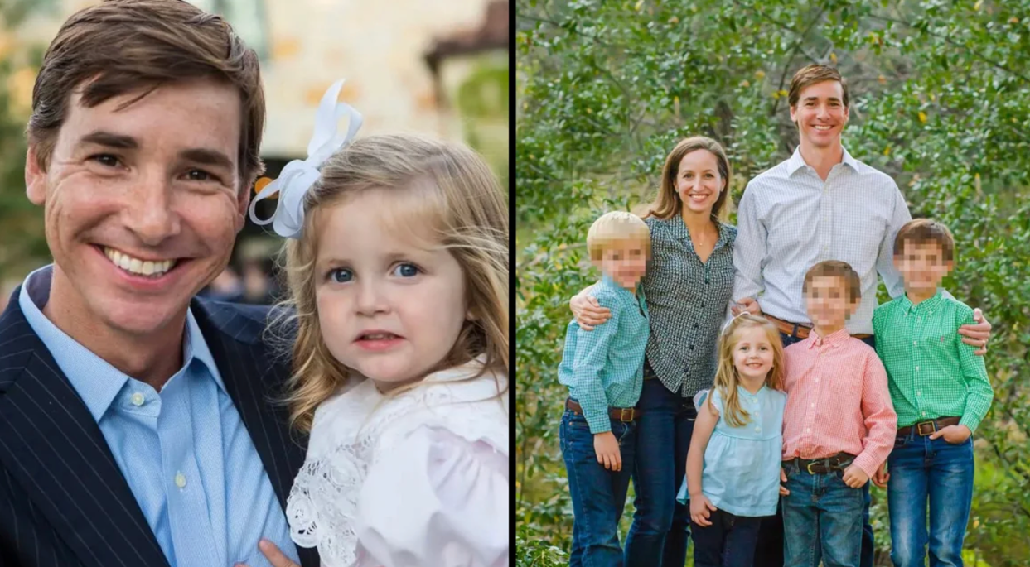

Our AMS Dennis Thurman is inviting everyone to
join him in prayer for our Churches and Pastors:
- Panther Creek- Ronald Greene
- Pinnacle- Heath Davis
- Pleasant Balsam- Brandon Mendez

Special Prayer Request

Please remember Lila Murdock in your prayers as she has had a light stroke and looking at some rehab time. Lila is the wife of Paul Murdock, pastor of Calvary Baptist Church in Canton. They will appreciate your prayers during this time!

Pastors Conference

Monday morning Pastors’ Conferences are held on Monday Mornings at 10:00AM here at the Associational Office. We would love to have you join us!

Men’s Prayer Meeting

The Men’s Prayer Group will meet on Saturday mornings at 7:30AM at Barberville Baptist Church. All are welcome to come!

Office Closed
Our office will be closed Monday, April 10, 2023.

Employment Opportunities

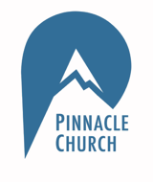
Pinnacle Church is hiring a position in student ministry. This would be to lead the middle school and high school ministries full time. For more information and to apply, please visit: https://pinnacle.elexiochms.com/external/form/34b86081-50b8-4406-9c2e-0a27bb9d37fa

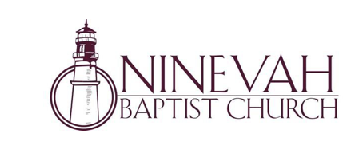
Ninevah Baptist Church is accepting resumes for a part time director of Music Ministries. If interested, please send resumes to PO Box 38. Waynesville, NC 28786

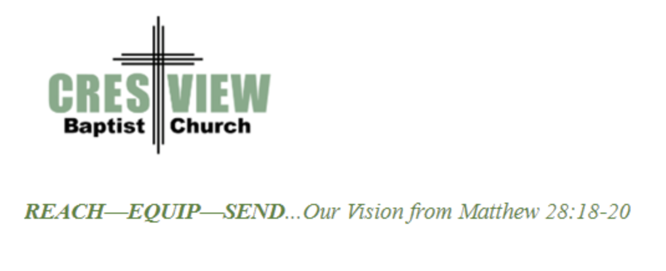
Crestview Baptist Church is now accepting resumes for a part time Worship Leader. If interested, please submit resume to 3258 Pisgah Drive Canton, NC 28716. You can also contact the church at: 828-648-1110 with any questions.

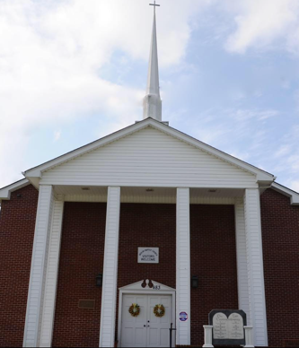

Beulah Baptist Church is looking for a Youth/Children’s Pastor. If you are interested, please contact Pastor Barry Clark at 828-508-8889.

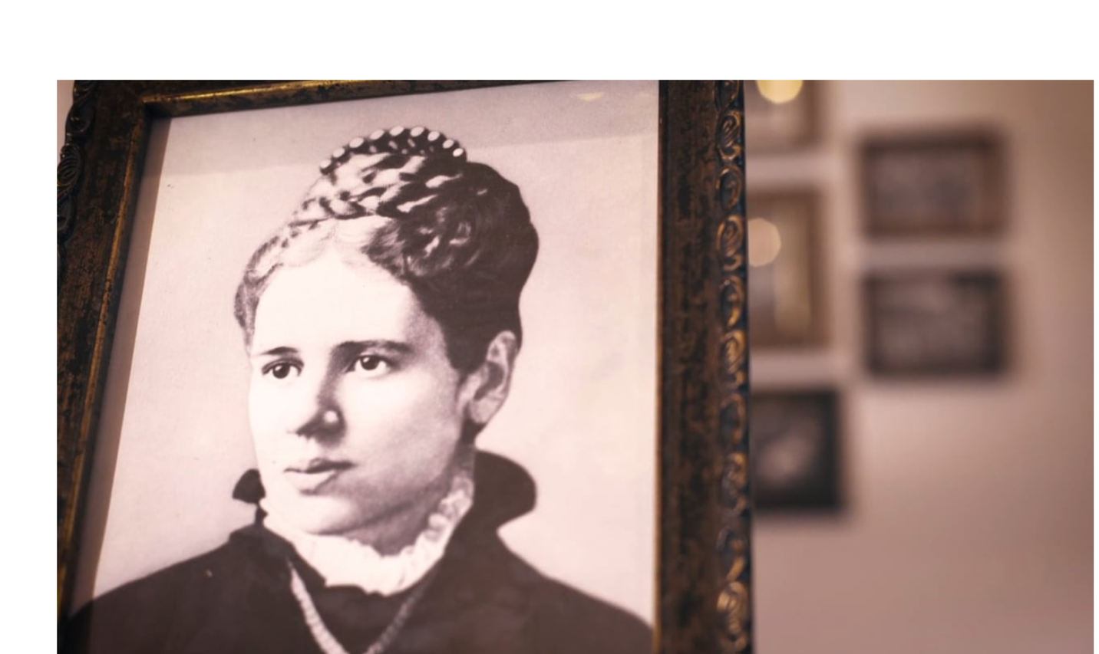
Annie Armstrong Easter Offering

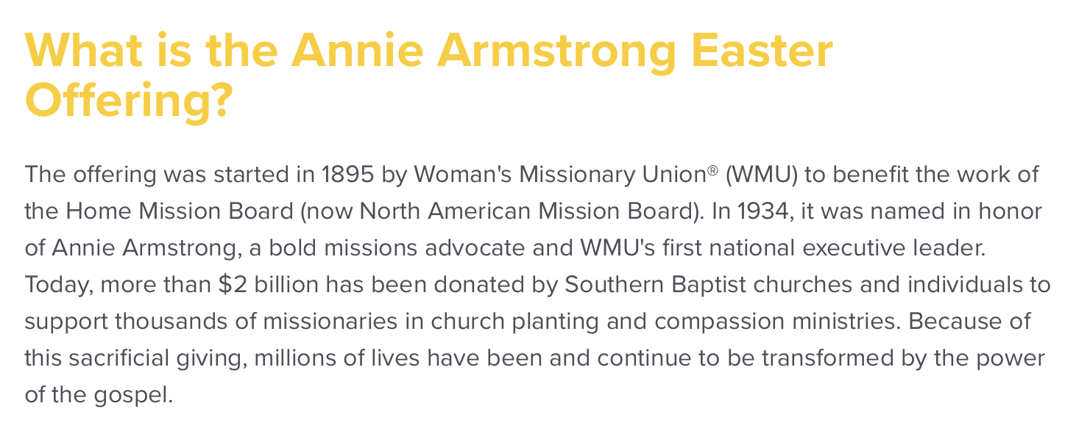

You can learn more information on the Annie Armstrong Easter Offering at:
https://www.anniearmstrong.com

